Thomas R. Proctor
High School
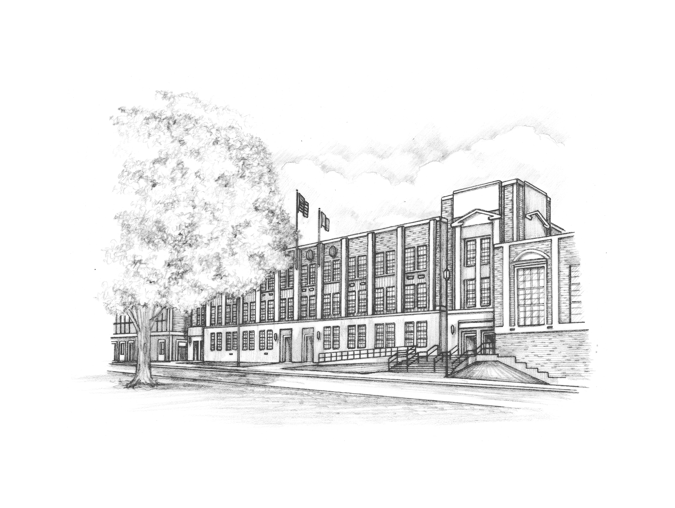
Program of Studies
2020-2021

Administration

Joshua Gifford .................................... High School Principal
Beth Pedulla................................ Grade 9 Assistant Principal
Tammy Sharpe ...........................Grade 10 Assistant Principal
Ken Szczesniak .....................Academy C Assistant Principal
Stacy Pekala.......................... Academy D Assistant Principal

Administrative Director of Curriculum & Instruction K-12
Steven Falchi

Superintendent of Schools
Mr. Bruce Karam

Utica City School District Board of Education
Louis D. LaPolla, President
Robert Cardillo, Vice President
Donald Dawes
Joseph Hobika, Jr.
Anthony LaPolla
Daniel N. Padula
Christopher J. Salatino
Table of Contents

English……..................................................................................................................................2

English as a New Language (ENL)............................................................................................. 6

Fine Arts…..................................................................................................................................10
Art
Music

World Languages (LOTE)...........................................................................................................17

Mathematics…............................................................................................................................23

Naval Science (NJROTC)........ ..................................................................................................29

Occupational Education…….......................................................................................................32
Business
Technology

Physical Education……..............................................................................................................42

Special Education......................................................................................................................44

Science…...................................................................................................................................45

Social Studies …........................................................................................................................50

CTE............................................................................................................................................54
Career Pathways / Tech Prep Program

Acceleration Guidelines……......................................................................................................54

Guidance and Support Services……........................................................................................ 57

Diploma and Graduation Requirements………......................................................................... 58

English
The English Department course offerings are structured to accommodate all students, as well as meet the requirements mandated by the New York State Education Department. In order to graduate, students must earn 4 credits in English and achieve a passing score on the Regents Examination in English Language Arts. All English classes, regardless of level, are aligned to the Common Core Learning Standards for the state of New York in reading, writing, speaking, and listening for information and understanding; literary response and expression; critical analysis and evaluation; and social interaction. Each class, at every level uses a local examination at the completion of the course.

Students failing to meet the NYS English Language Arts graduation requirement by the second semester of their junior year must be enrolled in the appropriate level of remedial sections of Language Arts Lab 12 (described below).

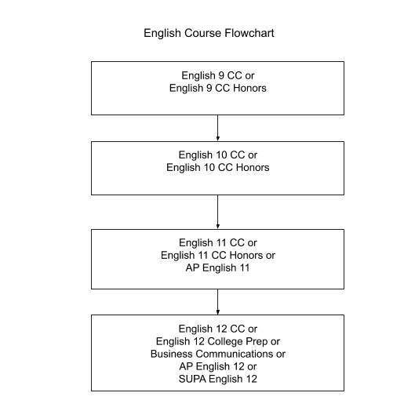

ENGLISH
English 9 CC
The English 9 course is designed to support the four Common Core Learning Strands. Students are introduced to the various literary genres from a diverse number of sources: poetry (including the epic), short stories, dramas, novels (including short fiction), and short non-fiction. The literature provides continuous practice in the development of reading comprehension skills and serves as a source for the development of basic competency in the completion of fundamental writing tasks. A review of grammar and punctuation is included in writing instruction that emphasizes paragraph development and whole essay planning. Writing activities provide instruction and review in spelling, vocabulary development, and language use. Classroom discussions of the literature provide the basis for development and refinement of both speaking and listening skills.
- Recommended Grade Level: 9
- Evaluation: Local exam at the conclusion of the year
- Credit: 1 unit - 1 year

English 9 CC Honors
The English 9 Honors course is designed to support the four Common Core Learning Strands. Students will read, write, listen, and speak for information, literary response, critical analysis, and social interaction. Various literary genres will be covered including short stories, novels, poetry, and drama. An emphasis will be placed on writing instruction including grammar, vocabulary development, sentence fluency, and paragraph organization. This is an intensive and rigorous level course work.
- Recommended: A score of level 3 or higher on the Grade 8 ELA Assessment, a final Grade 8
English course grade of 80 or greater and a score of 85 or greater on the Grade 8 final
exam
- Evaluation: Local exam at the conclusion of year
- Credit: 1 unit - 1 year
- Student must maintain an 80 average in order to remain at the Honors level

English 10 CC
The English 10 curriculum is designed to support the four Common Core Learning Strands.The English 10 students continue to study various literary genres: poetry (as it relates to larger pieces of literature), short stories, dramas, novels (including short fiction), and short non-fiction. The literature from a diverse number of sources provides continuous practice in the development of reading comprehension skills and serves as a source for the development of basic competency in the completion of fundamental writing tasks. A review of grammar and punctuation is included in writing instruction that emphasizes paragraph development and whole essay planning. Writing activities provide instruction and review in spelling, vocabulary development, and language use. Classroom discussions of the literature provide the basis for development, and refinement of both speaking and listening skills.
- Recommended Grade Level: 10
- Prerequisite: Completion of English 9
- Evaluation: Local exam at the conclusion of the year
- Credit: 1 unit - 1 year

English 10 CC Honors
The English 10 Honors course is designed to support the four Common Core Learning Strands. Students will continue to work with a variety of literary genres: the short story, the novel, poetry, drama, and non-fiction. Students will develop reading and comprehension skills, critical analysis and evaluation, and mastery in various forms of writing tasks. Teachers will provide the opportunity for students to explore and become proficient in critical thinking and writing skills. A writing portfolio will be kept. This is an intensive and rigorous level course work.
- Recommended: Completion of Grade 9 English Honors with an 85 or greater and a score of
85 or greater on Grade 9 English Honors final exam or completion of 9th Grade English
with a 90 or greater and an 85 or greater on 9th Grade English final exam
- Evaluation: Local exam at the conclusion of year
- Credit: 1 unit - 1 year
- Student must maintain an 80 average in order to remain at the Honors level

English 11 CC
Students are involved in intensive reading, writing, and listening activities as part of the curriculum in preparation for taking the Regents Examination in English Language Arts. Passing this exam is a graduation requirement. Practice for the English Regents Exam is embedded within course work as students read, discuss, and write about fiction and non-fiction texts as well as poetry. All students, regardless of passing the Regents exam, must take the final exam (locally developed) at the completion of the year.
- Recommended Grade Level: 11
- Prerequisite: completion of English 10
- Evaluation: Regents exam and local examination at the conclusion of the year
- Credit: 1 unit - 1 year

English 11 CC Honors
This course offers a balance for students who are not interested in pursuing academics on the 11 AP level by providing an opportunity to continue with the grade 9 and 10 honors track. Curriculum work includes but is not limited to: short stories, novels, poetry, non-fiction, and a variety of writing approaches including argumentative and analytical writing. Throughout the year, students prepare for the Regents Examination in English Language Arts while working diligently to increase critical writing and reading skill levels. The course will prepare students for advanced academic work without the added stress of the AP test. This is an intensive and rigorous level course work.
- Recommended Grade Level: 11
- Recommended: Completion of Grade 10 English Honors with an 85 or greater and a score of 85 or greater on Grade 10 English Honors final exam or completion of the 10th Grade English with a 90 or greater and an 85 or greater on 10th Grade English final exam
- Evaluation: Regents exam and local examination at the conclusion of the year
- Credit: 1 unit - 1 year

AP English 11
Advanced Placement English Language and Composition is a course designed for students to develop their skills as readers and writers in a variety of prose from different periods, disciplines and rhetorical contexts. Students will read complex and mature texts that will develop their analytical skills. Students will write in a variety of forms such as narrative, exploratory, expository and argumentative. There is an emphasis on correct grammar usage and highly developed vocabulary understanding. The course will culminate in the AP exam and completion of the Regents Examination in English Language Arts. Students are selected based on course grades and a teacher recommendation.
- Recommended Grade Level: 11
- Recommended: Completion of English 10 with a minimum grade of 70
- Evaluation: AP exam in English Language and Composition in May; Regents exam and
local final exam in June
- Credit: 1 unit - 1 year

English 12
This course is designed for the senior student who needs to develop practical abilities in English Language Arts. A wide range of reading is included in the course from various authors and genres to encourage the habit of recreational reading, but the emphasis of the course is also directed toward communication skills necessary for various vocations. Corrective work is generally necessary in writing skills and this is complemented by work in developing critical reading, viewing, and listening skills demanded by the use of newspapers, magazines, television, and film. There are short papers and research projects that require using some library skills.
- Recommended Grade Level: 12
- Recommended: English 11 course credit and a passing score on the Regents exam
- Evaluation: Local final exam in June
- Credit: 1 unit - 1 year

AP English 12
AP Literature and Composition is a college-level course for students who have demonstrated superior academic achievement and skills. The course literature is comprised of a wide range of authors, genres, and periods. However, the emphasis is on an in-depth study of poetry and prose as a means of developing the ability to analyze, interpret, and evaluate works of literature at the college level, as tested on the AP exam. Each student writes a variety of analytical and critical papers each marking period, including a research-based paper.
- Recommended Grade Level: 12
- Recommended: English 11 and a minimum grade of 70 on the Regents exam
- Evaluation: AP exam in Literature and Composition in May; local final exam in June
- Credit: 1 unit - 1 year

English 12 College Prep
This course is designed to support students in the transition from high school to college by fostering collegiate-level reading, writing, listening, and speaking skills. Students work with a variety of texts from a wide range of authors and genres with an emphasis on engaging in the analytical discussions and developing the critical essays they will be expected to complete in college. The fourth year of the academic English program emphasizes an integrated approach to the study of British literature, multi-paragraph writing, grammar, and methods of research for the college bound student. In literature the student studies thematic essays, biographies and autobiographies, short stories, epics, poems, and plays of varied genres and time periods, ranging from Old to Modern English.
- Recommended Grade Level: 12
- Recommended: English 11 course credit and a passing score on the Regents exam
- Evaluation: Local final exam in June
- Credit: 1 unit - 1 year

SUPA English 12
Syracuse University Project Advance (SUPA) is a dual-credit course in conjunction with Syracuse University. There is a substantially reduced tuition cost required. Financial aid is available. The course teaches critical writing and reading skills to 12th grade students and emphasizes strategies students can use to develop as critical readers, writers and thinkers. The course challenges students to understand that effective communication requires an understanding of many complex factors. Students will also study texts that bring awareness to the community around them. Both formal and informal writing will be required.
- Prerequisite: Seniors with an overall grade average of 85+ in their Junior year
- Credit: 1 unit - 1 year
ELA Academic Intervention Services (AIS) Program

As mandated by the State of New York Education Department Regulations (Part 100), students who are identified as being at-risk of not meeting state standards on the Regents Examination in English Language Arts must be enrolled in a course that will address their needs in order to be successful on this exam. Each level of this program stresses basic language arts, reading, and writing skills. Once entered into the program, students can only exit from the program by passing the Regents Examination in English Language Arts. Each level of this program is designed to address the needs of students in a progressive manner. Students will be placed in the appropriate level language arts class commensurate with the cohort year upon entering grade 9. ELA Academic Intervention Services are instructional support services above and beyond English coursework and are non-credit bearing courses.

ELA Academic Intervention Services Eligibility:
- Receiving a level 1 or level 2 on the Grade 8 ELA assessment (state mandated)
- Entering a NYS school for the first time since grade 9 (example: student comes from a state without state-wide writing assessments)
- Teacher recommendation after grade 9 (if student did not exhibit sufficient abilities on the grade 8 assessment)
- Receiving a grade under the mandated passing level of diploma—applies to grade 11 and grade 12 students
- No score on the grade 8 ELA assessment (incoming freshmen) or no score from another NYS school for Regents Examination in English Language Arts

Language Arts Lab 9 (AIS): A one year, non-credit bearing course for assisting students in building analytical reading and writing skills as well as introducing study skills necessary for success in high school. All literature and thematic units are based on improving the overall language arts skills needed to be successful. Students who are enrolled in English 9 CC classes should be assigned to this level.

Language Arts Lab 10 (AIS): A one year, non-credit bearing course that introduces students to the specific reading and writing tasks of the English Regents Exam. Specific exam review books and assignments are given to practice the specific writing skills necessary to complete writing tasks. Students who have taken Language Arts 9 and are enrolled in English 10 CC should be assigned this level.

Language Arts Lab 11 (AIS): A one year, non-credit bearing course designed to support students in preparing for the English Regents Exam by providing focused instruction in analytical reading and writing as well as general test taking strategies. Students who have taken Language Arts 10 and are enrolled in English 11 CC should be assigned to this level.

Language Arts Lab 12 (AIS): A semestered, non-credit bearing course for students who have not passed the English Regents Exam by their senior year. Students who were identified by one of the above listed criteria will be able to exit the program with a passing score on the exam and must be assigned to this course for as many semesters as needed to reach a passing score as per Part 100 of the New York State Education Department Regulations.

English as a New Language (ENL)

English as a New Language (ENL), is a specific discipline. An ENL approach to English instruction recognizes that English is not the native language of the student. It is attentive to the problems in English confronted by non-native speakers of the language. ENL instruction focuses on the development of overall communicative and linguistic competence in listening, speaking, reading and writing English. Attention to each of these constitutes an integral part of all ENL instruction as the student moves from lower to higher levels of language learning in the ENL program. ENL instruction is provided to individual students at the level most appropriate for them. The ENL program includes the five levels of instruction: entering, emerging, transitional, expanding, and commanding. A student must demonstrate mastery of the instructional objectives of a specific level and achieve the next level on the NYSESLAT before advancing to a higher level.

- Recommended Grade Level: 9-12
- Prerequisite: Non-native speaker of English
- Evaluation: Local and state exam - New York State English as a Second Language Assessment Test (NYSESLAT)
ENL 1A Bridges
This course is designed for SIFE students in the entering and emergent stage of English Language acquisition. The students are taught within the framework of the New York State Next Generation English Language Arts Learning Standards. The emphasis in this course is placed on acquiring foundational skills and content through the use of literacy strategies and trade books. The focus is on using oral language and home language to acquire content as well as developing reading and writing through specific tasks and project-based learning. Students within this level are categorized in the lower range of the NYSESLAT, and may have limited or very low levels of literacy in their native language. This course uses an integrated thematic curriculum that was developed by the graduate studies team at CUNY. This class meets for two periods every day.
- Credit: 1 year: 1 ELA credit +1 Elective credit

ENL 1B
This course is designed for students at the mid-range of the emerging level of English Language Proficiency. The students are taught within the framework of the New York State Next Generation English Language Arts Learning Standards. There is an emphasis on listening, speaking, reading, and writing skills. This class meets for two periods every day.
- Credit: 1 year: 1 ELA credit +1 Elective credit

ENL 1C
This course is designed for students at the high range of the emerging or low transitional level of English Language Proficiency but may include all beginning levels depending on individual student needs. The students are taught within the framework of the New York State Next Generation English Language Arts Learning Standards. There is an emphasis on listening, speaking, reading, and writing skills. This class meets for two periods every day.
- Credit: 1 year: 1 ELA credit +1 Elective credit

ENL 2A
This course is designed to meet the needs of English Language Learners (ELLs) at the lower transitional level of English language proficiency. Students will receive instruction in listening, writing, reading, and speaking. The students are taught within the framework of the New York State Next Generation English Language Arts Learning Standards. This class meets for two periods every day.
- Credit: 1 year: 1 ELA credit +1 Elective credit

ENL 2B
This course is designed to meet the needs of LEP/ELL students at the mid-range transitional level of English Proficiency. The students will receive instruction in listening, speaking, reading, and writing. The students are taught within the framework of the New York State Next Generation English Language Arts Learning Standards. The class meets for two periods every day.
- Credit: 1 year: 1 ELA credit

ENL 2C
This course is designed for students at the high transitional level of language proficiency. The students are taught within the framework of the New York State Next Generation English Language Arts Learning Standards. The class meets for two periods per day.
- Credit: 1 year: 1 ELA credit
ENL 3
This course is designed for 9th grade students in the Expanding Level of English Language Proficiency. The students are taught within the framework of the New York State Next Generation English Language Arts Learning Standards. There is an emphasis on listening, speaking, reading, and writing skills. Students in this class are placed in grade appropriate English classes. The class meets for one period per day.
- Credit: 1 year: 1 Elective credit
ENL 4
This course is designed for the 10th grade students in the Expanded Level of English Language Proficiency. The students are taught within the framework of the New York State Next Generation English Language Arts Learning Standards. There is an emphasis on listening, speaking, reading, and writing skills. Students in this class are also placed in grade appropriate English classes. The class meets for one period per day.
- Credit: 1 year: 1 Elective credit

ENL Regents 2
This course is designed for students who will be taking the English Language Arts Regents in Grade 11 for the first year. The students are taught within the framework of the New York State Next Generation English Language Arts Learning Standards. Smaller class sizes and veteran teachers provide intense ELA preparation. The class meets for two periods per day.
- Credit: 1 year: 1 ELA credit

ENL Regents 2 Intensive
This course is designed for students who have taken the English Language Arts Regents but did not pass it yet. The students are taught within the framework of the New York State Next Generation English Language Arts Learning Standards. Smaller class sizes and veteran teachers provide intense ELA preparation. The class meets for two periods per day.
- Credit: 1 year: 1 ELA credit

ENL Regents 3
This is an ENL Regents 3 course for students who will be taking the English Language Arts Regents Exam. The students are taught within the framework of the New York State Next Generation English Language Arts Learning Standards. Smaller class sizes and veteran teachers provide intense ELA preparation. This course satisfies the New York state requirement for Expanding level students. Students are also required to take a Grade 11 English course. The class meets for one period per day.
- Credit: 1 year: 1 Elective course

ENL 12
This course is designed for students who have passed the English Language Arts Regents. The students are taught within the framework of the New York State Next Generation English Language Arts Learning Standards. There is an emphasis on listening, speaking, reading, and writing skills in preparation for college and/or the workplace. Students in this class are in Grade 12. The class meets for one period per day.
- Credit: 1 year: 1 ELA credit

Language Arts ELL
ENL Language Arts gives new to English students or low literacy ELLs opportunities to practice phonics, spelling, and foundations of reading as such students are not able to benefit from grade-level ELA/AIS. This class includes some Students with Interrupted or Limited Formal Education (SIFE) who have been in school for a few years, yet need to accelerate progress in their academics.
Credit: N/A

ENL Lab
ENL lab is designed for students who scored Commanding on NYSESLAT to provide additional support in academics for two years after they achieved proficiency. Class meets for one period every other day.
Credit: N/A

Sheltered Content Courses
Sheltered content courses are offered in math, social studies, and science. These classes are designed for ELL students who need extra linguistic support to master content. Sheltered courses are taught by content teachers who have received training in teaching ENL students, and in certain cases co-teaching models with an ENL teacher is used to meet students’ needs. The student make-up is solely ELLs. Students enrolled in sheltered courses must fulfill NYS Regents requirements for graduation.
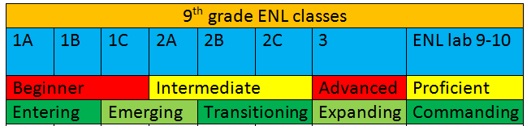
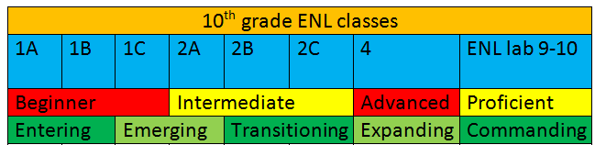
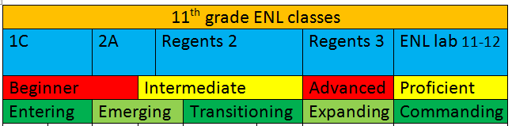
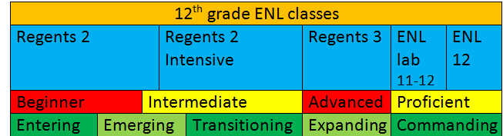
ART COURSES FLOW CHART 2019-2020
Art 1

Grade Level: 9-12
Prerequisite: None
Evaluation: Local Examination and Portfolio
1 Unit – 1 Year *Required for Art Sequence

Ceramics & Sculpture

Grade Level: 11, 12
Prerequisite: 85 or higher in Art 1 & Art 2
Evaluation: Portfolio Review
Critique and Evaluation
1 Unit – 1 Year
Communication Design

Grade Level: 11, 12
Prerequisite: 85 or higher in Art 1 & Art 2
Evaluation: Portfolio Review
Critique and Evaluation
1 Unit – 1 Year
Fashion Design

Grade Level: 11, 12
Prerequisite: 85 or higher in Art 1 & Art 2
Evaluation: Portfolio Review
Critique and Evaluation
1 Unit – 1 Year

Art 2: Drawing & Painting

Grade Level: 10-12
Prerequisite: 80 or above in Art 1
Evaluation: Portfolio
Local Examination
1 Unit – 1 Year *Required for Art Sequence

Creativity in the Arts (MVCC)
Photography (MVCC)

Grade Level: 11, 12
Prerequisite: 85 or higher in Art 1 and Art 2
Evaluation: Portfolio Review
Critique
Local Examination
1 Unit – 1 Year, Dual Credit

Digital Art (Night School)

Grade Level: 11, 12
Prerequisite: 85 or higher in Art 1 and Art 2
Evaluation: Portfolio Review
Critique
Local Examination
1 Unit – 1 Year

Advanced Independent Art

Grade Level: 11, 12
Prerequisite: Art 1, Art 2, Portfolio Review, Permission from Instructor, Department Head Approval
Evaluation: Portfolio Critique and Evaluation
Local Examination
1 Unit – 1 Year

Art
The art curriculum at Thomas R. Proctor High School is designed to fulfill the needs of many students interested in following an art sequence or who might be considering a career in the visual arts and design. Students who plan to continue taking art courses after Art 1 are strongly encouraged to consult with the art faculty regarding their schedules. Each upper level course focuses on portfolio development.

COURSE OFFERINGS
Art 1 - Studio in Art Art 2 - Drawing and Painting
Ceramics & Sculpture Communication and Design
Creativity in Art (MVCC) Digital Art (Night School)
Fashion Design Photography (MVCC)
Advanced Independent Study

Minimum Requirements
Students need to earn one (1) unit of art and/or music to receive either a Regents or local high school diploma.

Diploma Requirement
Art 1:Studio Art is the course recommended to meet the one unit of credit for the graduation requirement. For students wishing to obtain a sequence in Art, the following options are available:

Three-Unit Sequence in Comprehensive Visual Arts
To receive Regents credit for this sequence, students must pass the foundation courses Art 1 and Art 2, and at least one additional unit of credit in Art selected from the department offerings.

Five-Unit Visual Arts Education Sequence
To receive Regents credit for a five-unit visual sequence, students must pass Art 1 and Art 2 and earn at least three additional units of credit in advanced courses selected from department offerings.

Art 1: Studio Art
Art 1 allows students who are interested in Art to acquire the 1 credit required in the Arts for graduation. The course is designed to address areas, which will allow for students to develop a better understanding of the aesthetics and appreciation of art through the exploration and examination of culture, history and artistic media and tools. An appreciation of the impact of art today and career exploration will be emphasized. It is a course which is involved with utilizing studio techniques to create art projects as well as the appreciation of other art and artists. Emphasis is placed on using the Elements and Principle of Design and their manipulation in a work of Art. Both two and three-dimensional projects are employed to stimulate the students’ ability to think critically and make judgments about the art world.
- Credit: 1 unit - 1 year
- Recommended Grade Level: 9, 10, 11, or 12
- Evaluation: Local Examination, Portfolio Review
- Also offered through the night school program

Art 2: Drawing and Painting
Art 2 is a second year, two-semester course open to students who have completed Art 1. This course covers the principles and techniques of the artist in the development of drawing and painting. Structure, design and all the elements of art are explained, demonstrated, and utilized first in drawing and then in painting, with utmost stress being placed on the creative aspects of every problem. A variety of drawing media such as pencil, charcoal, chalk, and pen are utilized. In painting, watercolor, acrylics, as well as mixed media are used. Attention is given to still life, figure drawing, observations, drawings, landscape, and the use of sketchbooks. Field trips to museums are incorporated into the program whenever possible.
The basic theories and techniques of color perspective, drawing, and design learned in Art 1 are applied to create finished art projects suitable for use in their portfolio. Students are expected to create and finish ten (10) pieces of work for their portfolio.
- Recommended Grade Level: 10, 11, 12
- Recommended: Art 1
- Evaluation: Portfolio review, local examination
- Credit: 1 unit - 1 year

Ceramics/Sculpture
Ceramics is open to all students who have completed Art 1 and Art 2. It is an elective course designed to familiarize students with wedging, building shapes and forms, slip painting, loading and unloading the kiln, and throwing a pot on a Potter’s wheel. It is definitely a hands-on, get involved course in creating two and three-dimensional forms and allows students the opportunity to combine and explore themselves functional and non-functional products, as well as other 3-Dimensional exploration/materials.
- Recommended Grade Level: 11, 12
- Recommended: Art 1 and Art 2
- Evaluation: Project review, critique, and evaluation
- Credit: 1 unit - 1 year

Communication & Design
This course is one of the classes available to complete a sequence in the visual arts. The content of this class is based upon the foundational knowledge gained in Art 1 and Art 2. Content is based upon the students’ working knowledge of the Elements of Art and the Principles of Design. The student must become familiar with the technical aspects of Adobe Photoshop and Adobe Illustrator, as well as improving their drawing and painting skills. Advertising, illustration, and graphic design are the creative medium to move ideas and information to the minds of others. Students will be expected to be familiar with the opportunities in the fields of advertising illustration, graphic design, and marketing for services and products.
- Recommended Grade Level: 11-12
- Recommended: Art 1 and Art 2
- Evaluation: Local examination, portfolio review
- Credit: 1 unit - 1 year

Creativity in the Arts (MVCC)
This course introduces students to the fundamental principles of creativity with an emphasis on understanding historically significant art styles. Students explore various types of visual expression and apply creative problem solving principles to both two-dimensional and three-dimensional projects in a variety of media. Students are introduced to the masters, practices, and careers of painting, sculpture, graphic arts, graphic design, animation, film, digital media, illustration, and photography.
- Recommended Grade Level: 11, 12
- Recommended: Art 1 and Art 2
- Evaluation: Local exam, critique and portfolio review
- Credit: 1 unit - 1 year, 3 college credits awarded through MVCC

Fashion Design
This course is designed to introduce students to the world of fashion design. The course will provide students with the opportunity to experience the development of apparel from sources of inspiration to a finished product. Application of the elements and principles of design will be used to create fashion illustrations and garments. This course will include an overview of the history of fashion trends, designers, terminology, fashion illustration, basic sewing, and design apparel.
- Recommended Grade Level: 11-12
- Recommended: Art 1 and Art 2
- Evaluation: Local examination and portfolio review
- Credit: 1 unit - 1

Photography (MVCC)
Studio in Black and White Photography is an advanced course for students who have completed Art 1 and Drawing and Painting Art 2, or, by special permission of the Art Department. This course is designed to teach students the technical and creative elements of the camera and the darkroom and to help students to consider Photography as an art form and as a possible vocation. Although the student must become familiar with the technical aspects of the camera and the darkroom, the emphasis will remain with Photography as a creative form of communication and composition. The student should have access to a 35mm camera to gain a maximum of experience from this course. Darkroom materials are provided, but printing paper and film expenses have to be assumed by the student.
- Recommended Grade Level: 11, 12
- Recommended: Art 1 and Art 2
- Evaluation: Local exam and portfolio review
- Credit: 1 unit - 1 year, 3 college credits awarded through MVCC

Advanced Independent Art
Independent Art is a course for students who have completed all of the course offerings in the Department and wish to pursue an art career. It can be an advanced course in any of the areas that are offered, or a course, which will offer an opportunity to explore a field of art, which is not offered at Thomas R. Proctor High School. Portfolio for college admission is also completed. This course requires instructor and department head approval after a portfolio review. At that time, an independent program will be devised.
- Recommended Grade Level: 11, 12
- Recommended: Portfolio review, instructor and department head approval, Art 1, and Art 2
- Evaluation: Portfolio critique, Evaluation, and Local Examination
- Credit: 1 unit - 1 year

Digital Art (Night School)
Digital Art is a course developed for students who have interest idigital technology as an essential part of the creative process. Students will develop creative awareness by using technology as an art tool combined with their knowledge of fine art. Using the elements of art and principles of design students will work through a rigorous curriculum to create a complete body of work through the use of digital technology. Programs such as Adobe Photoshop, Illustrator and InDesign will be used as an integral part of the course.
- Recommended Grade Level: 11-12
- Recommended: Art 1 and Art 2
- Evaluation: Portfolio review, critique and local examination
- Credit: 1 unit - 1

MUSIC COURSES FLOW CHART
Symphonic Orchestra

Grade Level: 9-12
Prerequisite: See String/Symphonic Orchestra
Evaluation: Performance Evaluation of the student’s musical growth
1 Unit – 1 Year

Music in Our Lives

Grade Level: 9-12
Prerequisite: None
Evaluation: Written Examination
1 Unit – 1 Year

String Orchestra

Grade Level: 9-12
Prerequisite: Permission of Instructor
Evaluation: Performance Evaluation of the student’s musical growth
1 Unit – 1 Year

Senior Choir

Grade Level: 10, 11, 12
Prerequisite: Previous Ensemble Experience
Evaluation: Performance Evaluation
1 Unit – 1 Year

Music Theory

Grade Level: 9-12
Prerequisite: Recommendation of Instructor
Evaluation: Performance Evaluation of the student’s musical growth
1 Unit – 1 Year

Mixed Choir

Grade Level: 9-12
Prerequisite: Previous Ensemble Experience
Evaluation: Performance Evaluation
1 Unit – 1 Year

11th & 12th Grade Band

Grade Level: 11, 12
Prerequisite: Previous Ensemble Experience
Evaluation: Performance Evaluation of the student’s musical growth
1 Unit – 1 Year

9th & 10th Grade Band

Grade Level: 9, 10
Prerequisite: Previous Ensemble Experience
Evaluation: Performance Evaluation of the student’s musical growth
1 Unit – 1 Year

Independent Orchestra

Grade Level: 9-12
Prerequisite: See String/Symphonic Orchestra
Evaluation: Performance Evaluation of the student’s musical growth
1 Unit – 1 Year

Music
The contribution of music to the curriculum is by nature a subjective one. Esthetic stimulus and response is the medium for communication. The objectives of the program of music are:

- To expand the ability to respond to music based upon the student’s natural love for it, with greater and deeper understanding through knowledge of its melodic, rhythmic and harmonic properties and experience with the art. By perceiving the structural elements or by understanding the organizational concepts of music, the development of musicality takes place. Skill, knowledge, and insight are basic to musical growth.
- To emphasize the intellectual and emotive qualities of music by helping students recognize the means of expression most suitable to them and to offer them the opportunity to explore and develop their talents in music.
- To involve all students to the extent of their musical capacity, making them more sensitive, discriminating, and creatively aware individuals.
- To involve all students to the extent of their musical capacity, making them more sensitive, discriminating, and creatively aware individuals.
- To acquaint students with their musical heritage. The total music program includes the great folk music and classics of the non-Western as well as the Western world in order that appropriate recognition can be given to all artistic expression which has contributed to present day culture.
- To motivate students to explore a variety of musical literature in order that they may discover the value of music as a desirable mode of expression. An appropriate musical setting is established through a repertory to include not only music of the past but of the present as well.
- To help students finds values through esthetic experiences.

Mixed Choir
This course is designed to extend the students’ knowledge of the vocal and choral techniques necessary for public performance. It develops the principles of proper voice technique and interpretation, which affect musicianship and musical style, including sight reading. All performances are a mandatory requirement of the course.
- Recommended Grade Level: 9-12
- Evaluation: Performance evaluation
- Credit: 1 unit - 1 year

Senior Choir
This elective course is designed to give the student extensive opportunities in solo and group performance in and out of school. The class, organized as a choir, is the school’s major vocal performing group, accomplishing extensive repertoire from all periods of music to fulfill student and performance needs. Emphasis is placed on the culmination and application of knowledge learned in Voice classes and/or Choir. All performances are a mandatory requirement of the course.
- Recommended Grade Level: 11, 12
- Evaluation: Performance evaluation
- Credit: 1 unit - 1 year

9th/10th Grade Band
Opportunity for musical development is provided by acquainting the student with good band literature. Small ensemble playing is also available. The band represents the school by means of concerts, appearances at athletic events, parades and community performances on special occasions. Private or group lessons are required. All performances are a mandatory requirement of the course.
- Recommended Grade Level: 9, 10
- Recommended: Permission of instructor, previous ensemble experience
- Evaluation: Performance evaluation of the student’s musical growth
- Credit: 1 unit - 1 year

11th/12th Grade Band
Extension of musical development is provided by acquainting the student with advanced band literature. Small ensemble playing is also available. The band represents the school by means of concerts, appearance at athletic events, parades and community performances on special occasions. Private or group lessons are required. All performances are a mandatory requirement of the course.
- Recommended Grade Level: 11, 12
- Recommended: Permission of instructor, previous ensemble experience
- Evaluation: Performance evaluation of the student’s musical growth
- Credit: 1 unit - 1 year

String Orchestra
This group meets every other day and provides students with beginning orchestral experience on their respective instruments over and beyond the practice demanded at home. Players are acquainted with quality orchestral music. Opportunity is provided for playing together in ensembles of all kinds. Public concerts provide the added experience of service to the school and community. Private or group lessons are required. All performances are a mandatory requirement of the course.
- Recommended Grade Level: 9-12
- Recommended: Permission of instructor, previous ensemble experience
- Evaluation: Performance evaluation of the student’s musical growth
- Credit: 1 unit - 1 year

Symphonic Orchestra
This group meets every other day and provides students with advanced orchestral experience on their respective instruments over and beyond the practice demanded at home. Players are acquainted with quality orchestral music. Opportunity is provided for playing together in ensembles of all kinds. Public concerts provide the added experience of service to the school and community. Private or group lessons are required. All performances are a mandatory requirement of the course.
- Recommended Grade Level: 9-12
- Recommended: Permission of instructor, previous ensemble experience
- Evaluation: Performance evaluation of the student’s musical growth
- Credit: 1 unit - 1 year

Music in Our Lives
This course allows students who are interested in Music to acquire the 1 credit required in the Arts for graduation. The course is designed to address areas, which will allow for students to develop a better understanding of the aesthetics and appreciation of music through listening, performing, using basic skills, composing, and technology. Guest speakers/educators/performers will be invited to share their musical experience with the students. Students will use the MIDI lab to fulfill the composing, performance, and technology aspects of the curriculum.
- Recommended Grade Level: 9-12
- Evaluation: Written examination
- Credit: 1 unit - 1 year

Music Theory
This course includes a review of the elements of music including staff and clefs, scales and key signature, time values/ rhythmic patterns, musical terms, melody, intervals, cadences, chords, form, and non-harmonic tones through the realization of figured bass and the study of root position chords and their inversions. Student composition is highlighted with an emphasis on form. The goal of this course is to instruct and familiarize serious music students in theory and musicianship in order to prepare them for entry into music institutions of higher learning.
- Recommended Grade Level: 9-12
- Evaluation: Performance evaluation of the student’s musical growth
- Credit: 1 unit - 1 year

Independent Orchestra
This group provides students with advanced orchestral experience on their respective instruments over and beyond the practice demanded at home. Players are acquainted with quality orchestral music. Opportunity is provided for playing together in ensembles of all kinds. Public concerts provide the added experience of service to the school and community. Private or group lessons are required. The student must be unable to be scheduled for String or Symphonic Orchestra in order to be scheduled for Independent Orchestra.
- Recommended Grade Level: 9-12
- Recommended: Permission of instructor
- Evaluation: Performance evaluation of the student’s musical growth
- Credit: 1 unit - 1 year

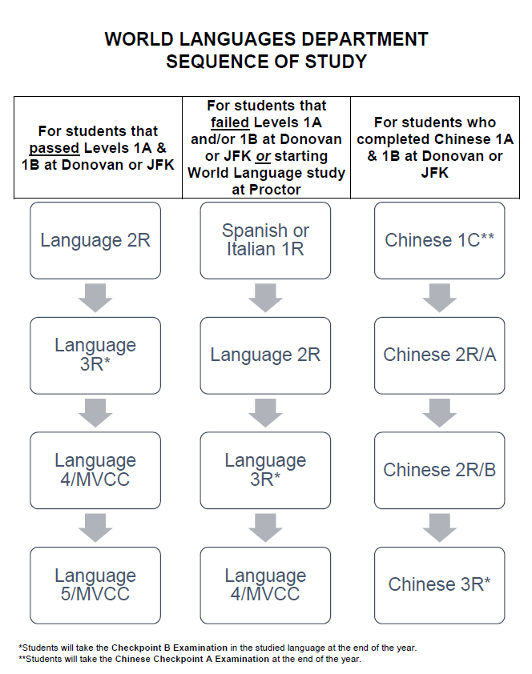
World Languages
Equipment and Teaching Aids
To help students achieve proficiency in communication, the World Languages Department has at its disposal the use of interactive and online software, SMART TVs, and the use of ChromeBooks. These teaching aids have been integrated into instruction at all levels to increase opportunities for the development of students’ language skills.

World Language Credit

1. Credit for study of less commonly taught languages by English dominant students.
The Comprehensive Checkpoint B Examinations in the most commonly taught foreign languages, (French, Italian, Spanish and Mandarin Chinese) are offered. When applied to less commonly taught languages, this section of the Commissioner’s regulations allows for the awarding of World Language credits if the language course or sequence is taught in accordance with the state syllabus and a Checkpoint B Comprehensive Examination is administered and completed successfully.

2. Credit for skills developed outside an English-speaking environment.
Students who have developed World Language communication skills outside an English-speaking environment most commonly include native speakers of languages other than English. Also included are English-dominant students who have either participated in foreign exchange programs or resided in other-than-English speaking environments as dependents of military or business personnel. In such cases, schools have the option of awarding foreign language credit based on a review of the student’s education and residence in the other-than-English speaking environment. Schools may award up to three units of language credit for each year of documented school attendance and residence in an other-than-English speaking environment, provided the experience occurred at age 11 or older and that the residence resulted in direct contact with the environment and its people.

(A) As specified in Section 100.5 [d]. Schools may award up to 3 units of language credit for each year of documented school attendance and residence in an other-than-English speaking environment, provided that experience occurred at age 11 or older and that the residence resulted in direct contact with that environment and its people. No more than a total of 5 units of LOTE credit may be awarded for school attendance and residence in an other-than-English speaking environment, regardless of the length of the experience. No credit may be awarded for residence in a bilingual home within an English-speaking environment because the amount of World Language learning which occurs in such situations cannot be predicted adequately.

Modern Language Study (French, Italian Spanish)
The approach to World Languages by the staff of Thomas R. Proctor High School is one that is recommended by most World Languages specialists in New York State. This approach stresses the communicative goals of the New York State Syllabus and involves the frequent “revisiting” of a series of common topics. The constant review and expansion of these topics is known as “spiraling.” Grammar topics are taught as they serve to satisfy the communicative needs of the students. Culture is taught as a context in which the language functions, as well as a manifestation of the creative energies and genius of the people who create it. At the basic and intermediate levels of each language, all World Languages courses are Regents track.

French 2R
This level continues to develop the speaking. Listening, reading, and writing skills acquired in French 1A and French 1B. By the end of this course, a student should be able to speak about oneself and one’s surroundings and ask for information as well as understand a native speaker speaking slowly on a specific topic. Emphasis will be placed on the student’s ability to function in everyday situations. There is a continued study of the French culture.
Recommended Grade Level: 9-12
Recommended: Successful completion of a World Languages 1R course or a passing grade on the French Checkpoint A Examination
Evaluation: Local Examination
Credit: 1 unit, 1 year

French 3R
This course is designed for students who have successfully completed French 2R and would like to further develop the language communication skills acquired during the preceding years. Emphasis will be placed on the student’s ability to function in everyday situations. Students will further develop their skills in listening, speaking, reading, and writing that are comprehensible to native speakers. By the end of the course, the student should have a fairly thorough understanding of the French culture and their customs. Students enrolled in French 3R will take the French Checkpoint B Examination at the end of the course.
Recommended Grade Level: 10-12
Recommended: Successful completion of French 2R
Evaluation: Local Examination and French Checkpoint B Examination
Credit: 1 unit, 1 year

French 4/MVCC (FR 191/192)
This dual-credit French class, offered through Mohawk Valley Community College (MVCC), is designed for students who have successfully completed the French Checkpoint B Examination and would like to further develop the skills acquired during the preceding years. This course is intended to be a review of French grammatical structures from previous levels, as well as additional tenses, including the subjunctive mood. Class discussion and presentations will be based on various readings from a variety of resources, both literary and current. This course offers the student to receive up to 6 college credits.
Recommended Grade Level: 11-12
Prerequisite: Successful completion of the French Checkpoint B Examination
Evaluation: Local Examination and MVCC Final Exams
Credit: 1 unit, 1 year and 6 college credits through MVCC

French 5/MVCC (FR 201/202)
This dual-credit French class, offered through Mohawk Valley Community College (MVCC), is a course designed for those students who have successfully completed French 4/MVCC and would like to further refine and perfect their French. This course includes a selection of literature and shows how speaking, listening, reading, and writing all bring about a heightened awareness and understanding of French literature. Class discussions and presentations will be based on various readings from a variety of sources. This course offers the student to receive up to 6 college credits.
Recommended Grade Level: 12
Prerequisite: Successful completion of French 4/MVCC
Evaluation: Local Examination and MVCC Final Exams
Credit: 1 unit, 1 year and 6 college credits through MVCC

Italian 1R
This course is designed to introduce students to elementary aspects of the Italian language and Italian culture. Emphasis is given to establishing a strong foundation in comprehension and basic communication on simple, everyday topics. Students will be able to comprehend main ideas and some detail on familiar topics and will be able to write an organized letter on a simple, familiar topic. Successful completion of this course results in the require 1 unit of World Language credit for the NYS graduation requirement.
Recommended Grade Level: 9-12
Prerequisite: n/a
Evaluation: Local Examination
Credit: 1 unit, 1 year

Italian 2R
This level continues to develop the speaking. Listening, reading, and writing skills acquired in Italian 1A and Italian 1B. By the end of this course, a student should be able to speak about oneself and one’s surroundings and ask for information as well as understand a native speaker speaking slowly on a specific topic. Emphasis will be placed on the student’s ability to function in everyday situations. There is a continued study of the Italian culture.
Recommended Grade Level: 9-12
Prerequisite: Successful completion of a World Languages 1R course or a passing grade on the Italian Checkpoint A Examination
Evaluation: Local Examination
Credit: 1 unit, 1 year

Italian 3R
This course is designed for students who have successfully completed Italian 2R and would like to further develop the language communication skills acquired during the preceding years. Emphasis will be placed on the student’s ability to function in everyday situations. Students will further develop their skills in listening, speaking, reading, and writing that are comprehensible to native speakers. By the end of the course, the student should have a fairly thorough understanding of the Italian culture and their customs. Students enrolled in Italian 3R will take the Italian Checkpoint B Examination at the end of the course.
Recommended Grade Level: 10-12
Prerequisite: Successful completion of Italian 2R
Evaluation: Local Examination and Italian Checkpoint B Examination
Credit: 1 unit, 1 year

Italian 4/MVCC (IT 191/192)
This dual-credit Italian class, offered through Mohawk Valley Community College (MVCC), is designed for students who have successfully completed the Italian Checkpoint B Examination and would like to further develop the skills acquired during the preceding years. This course is intended to be a review of Italian grammatical structures from previous levels, as well as additional tenses, including the subjunctive mood. Class discussion and presentations will be based on various readings from a variety of resources, both literary and current. This course offers the student to receive up to 6 college credits.
Recommended Grade Level: 11-12
Prerequisite: Successful completion of the Italian Checkpoint B Examination
Evaluation: Local Examination and MVCC Final Exams
Credit: 1 unit, 1 year and 6 college credits through MVCC

Italian 5/MVCC (IT 201/202)
This dual-credit Italian class, offered through Mohawk Valley Community College (MVCC), is a course designed for those students who have successfully completed Italian 4/MVCC and would like to further refine and perfect their Italian. This course includes a selection of literature and shows how speaking, listening, reading, and writing all bring about a heightened awareness and understanding of Italian literature. Class discussions and presentations will be based on various readings from a variety of sources. This course offers the student to receive up to 6 college credits.
Recommended Grade Level: 12
Prerequisite: Successful completion of Italian 4/MVCC
Evaluation: Local Examination and MVCC Final Exams
Credit: 1 unit, 1 year and 6 college credits through MVCC

Spanish 1R
This course is designed to introduce students to elementary aspects of the Spanish language and Spanish culture. Emphasis is given to establishing a strong foundation in comprehension and basic communication on simple, everyday topics. Students will be able to comprehend main ideas and some detail on familiar topics and will be able to write an organized letter on a simple, familiar topic. Successful completion of this course results in the require 1 unit of World Language credit for the NYS graduation requirement.
Recommended Grade Level: 9-12
Evaluation: Local Examination
Credit: 1 unit, 1 year

Spanish 2R
This level continues to develop the speaking. Listening, reading, and writing skills acquired in Spanish 1A and Spanish 1B. By the end of this course, a student should be able to speak about oneself and one’s surroundings and ask for information as well as understand a native speaker speaking slowly on a specific topic. Emphasis will be placed on the student’s ability to function in everyday situations. There is a continued study of the Italian culture.
Recommended Grade Level: 9-12
Recommended: Successful completion of a World Languages 1R course or a passing grade on the Spanish Checkpoint A Examination
Evaluation: Local Examination
Credit: 1 unit, 1 year

Spanish 3R
This course is designed for students who have successfully completed Spanish 2R and would like to further develop the language communication skills acquired during the preceding years. Emphasis will be placed on the student’s ability to function in everyday situations. Students will further develop their skills in listening, speaking, reading, and writing that are comprehensible to native speakers. By the end of the course, the student should have a fairly thorough understanding of the Spanish culture and their customs. Students enrolled in Spanish 3R will take the Spanish Checkpoint B Examination at the end of the course.
Recommended Grade Level: 10-12
Recommended: Successful completion of Spanish 2R
Evaluation: Local Examination and Spanish Checkpoint B Examination
Credit: 1 unit, 1 year

Spanish 4/MVCC (SP 191/192)
This dual-credit Spanish class, offered through Mohawk Valley Community College (MVCC), is designed for students who have successfully completed the Spanish Checkpoint B Examination and would like to further develop the skills acquired during the preceding years. This course is intended to be a review of Spanish grammatical structures from previous levels, as well as additional tenses, including the subjunctive mood. Class discussion and presentations will be based on various readings from a variety of resources, both literary and current. This course offers the student to receive up to 6 college credits.
Recommended Grade Level: 11-12
Recommended: Successful completion of the Spanish Checkpoint B Examination
Evaluation: Local Examination and MVCC Final Exams
Credit: 1 unit, 1 year and 6 college credits through MVCC

Spanish 5/MVCC (SP 201/202)
This dual-credit Spanish class, offered through Mohawk Valley Community College (MVCC), is a course designed for those students who have successfully completed Spanish 4/MVCC and would like to further refine and perfect their Spanish. This course includes a selection of literature and shows how speaking, listening, reading, and writing all bring about a heightened awareness and understanding of Spanish literature. Class discussions and presentations will be based on various readings from a variety of sources. This course offers the student to receive up to 6 college credits.
Recommended Grade Level: 12
Recommended: Successful completion of Spanish 4/MVCC
Evaluation: Local Examination and MVCC Final Exams
Credit: 1 unit, 1 year and 6 college credits through MVCC

Chinese 1C
This course will complete instruction in Checkpoint A of the New York State standards for the study of a World Language. Basic, formative grammatical concepts are practiced, reviewed and refined with the intent for success on the Chinese Checkpoint A Examination. Vocabulary will continue to be expanded upon. Students will converse in Chinese with each other and one-on-one with the teacher. Students will be expected to write a paragraph of at least 50 Chinese characters without the use of pinyin at the termination of this course. Practice in listening and reading will also be stressed.
Recommended Grade Level: 9
Recommended: Successful completion Chinese 1B
Evaluation: Chinese Checkpoint A Examination
Credit: 1 unit, 1 year

Chinese 2R/A
This is the first of a two-year sequence that will progress through the second level of traditional language study. This is a sequential course that continues the teaching of Chinese beginning at the Checkpoint B of the New York State Standards. The student enters the course with basic concepts of Chinese. Students build upon vocabulary, grammar and character writing. Students will begin to express themselves with some degree of fluency and fluidity in all four language skills of speaking, listening, writing, and reading.
Recommended Grade Level: 10
Recommended: Successful completion of Chinese Checkpoint A Examination
Evaluation: Local Examination
Credit: 1 unit, 1 year

Chinese 2R/B
This is the second of a two-year sequence that progresses through the second level of traditional language study. It is available only to students who have successfully completed the Mandarin Chinese sequence of courses through Chinese 2R/A. The student enters the course with solid skills and concepts of second language learning. The student also shows advancement progression of skills particularly in the writing and speaking of Chinese. In the sequential course Chinese 2R/B, the student will continue to build vocabulary, grammar and character writing to show extended knowledge of the language to where the student is able to sustain conversations in the target language and write in Chinese with an element of fluidity and continuity. This is approached through all four areas of language learning: speaking, listening, reading and writing. The student advances in ability of expression with an increased degree of fluency and fluidity from the Mandarin Chinese 2R/A course.
Recommended Grade Level: 11
Recommended: Successful completion of Chinese 2R/A
Evaluation: Local Examination
Credit: 1 unit, 1 year

Chinese 3R
This course focuses on the advancement of the four skills of language learning: speaking, listening, reading and writing. It is designed to increase proficiency so that students are capable of communicating with a native speaker in such areas as socializing, obtaining information and expressing personal feelings. Grammar and vocabulary are studied through a variety of activities that deal with these areas. Increased emphasis will be placed on the writing of Chinese characters to expand the student’s ability to write in Chinese. Students at this level are preparing for the Checkpoint B exam in June. Successful completion of this exam will provide students with a World Language sequence thus fulfilling one of the Advanced Regents Diploma requirements.
Recommended Grade Level: 12
Recommended: Successful completion of Chinese 2R/B
Evaluation: Chinese Checkpoint B Examination
Credit: 1 unit, 1 year
Mathematics
The mathematics offerings are structured to accommodate all students as well as meet the requirements mandated by New York State Education Department. All students must earn 3 credits in math in order to graduate. In addition, every student must pass the Integrated Algebra Regents or Common Core Algebra. To earn an Advanced Designation Diploma students must pass all three New York State Mathematics Regents Exams.

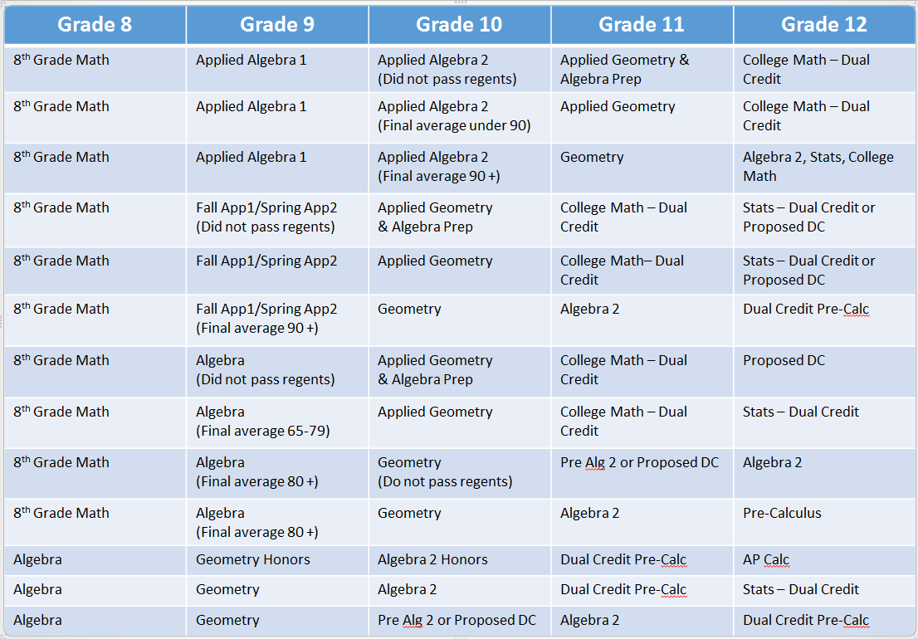
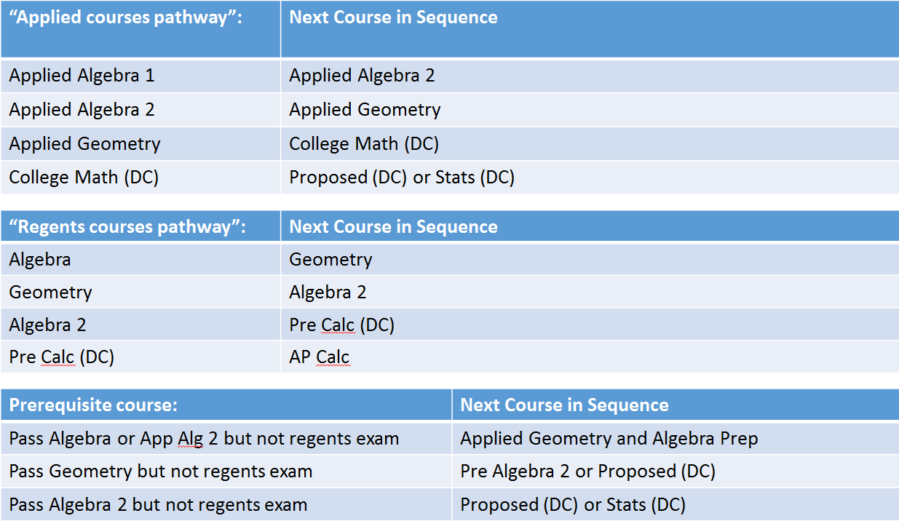
SECONDARY MATH COURSES OFFERED (3 ONE-YEAR REGENTS)

APPLIED ALGEBRA 1 Common Core* | PRE-ALGEBRA 2 CC
APPLIED ALGEBRA 1/ELL CC | ALGEBRA 2 CC
APPLIED ALGEBRA 2 CC | ALGEBRA 2 HONORS CC
APPLIED ALGEBRA 2/ELL CC | PRE-CALCULUS (MVCC DUAL CR)
ALGEBRA CC | AP CALCULUS
APPLIED GEOMETRY CC | STATISTICS (MVCC DUAL CR)
GEOMETRY CC | COLLEGE MATH (MVCC DUAL CR)
GEOMETRY HONORS CC | APPLIED ALGEBRA 1 MATH LAB CC
Bridges Math and Bridges Lab  *Common Core aligned courses are abbreviated as CC | APPLIED ALGEBRA 1/ELL MATH LAB CC
 | APPLIED ALGEBRA 2 MATH LAB CC
 | APPLIED ALGEBRA 2/ELL MATH LAB CC
 | Algebra Math Lab CC/ALGEBRA Prep

Applied Algebra 1 CC
This course serves the first of a two-year course in algebra CC. The Common Core Algebra Regents will be given at the end of the second year. Topics include a review of fractions, decimals, percents and integers, number theory, basic operations with monomials and polynomials, solving multi-step equations, ratio and proportions, graphing linear equations, statistics and problem solving techniques.
- Recommended Grade Level: 9 (Basic Pacing)
- Recommended: Completion of 8th Grade Math (65 to 79 average); Level 1 or Mid-Level 2 an 8th Grade Assessment
- Evaluation: Local final exam
- Credit: 1 unit - 1 year
Applied Algebra 1/ELL CC
This course is designed for foreign-born students who have the ability to speak English as their second language but have a limited background in mathematics. This course serves the first of a two-year course in algebra CC. The Common Core Algebra Regents will be given at the end of the second year. Topics include a review of fractions, decimals, percents and integers, number theory, basic operations with monomials and polynomials, solving multi-step equations, ratio and proportions, graphing linear equations, statistics and problem solving techniques.
- Recommended Grade Level: 9 (Basic Pacing)
- Evaluation: Local final exam
- Credit: 1 unit - 1 year
Applied Algebra 2 CC
This course serves as the second of a two-year course in Algebra CC. The CC Algebra Regents will be given at the end of the year. Topics include a review of skills learned in Applied Algebra 1 CC, basic operations with radicals, solving multi-step equations, solving systems of equations both linear and quadratic, factoring, graphing both linear and quadratic equations, statistics, and problem solving techniques.
- Recommended Grade Level: 10 (Basic Pacing)
- Recommended: Successful completion of Applied Algebra 1
- Evaluation: Common Core Algebra I Regents exam, local final exam
- Credit: 1 unit - 1 year

Applied Algebra 2/ELL CC
This course is designed for foreign-born students who have the ability to speak English as their second language but have a limited background in mathematics. This course serves as the second of a two-year course in algebra. The CC Algebra Regents will be given at the end of the year. Topics include a review of skills learned in Applied Algebra 1 CC, basic operations with radicals, solving multi-step equations, solving systems of equations both linear and quadratic, factoring, graphing both linear and quadratic equations, statistics, and problem solving techniques.
- Recommended Grade Level: 10 (Basic Pacing)
- Recommended: Successful completion of Applied Algebra 1/ELL
- Evaluation: Common Core Algebra I Regents exam, local final exam
- Credit: 1 unit - 1 year

Algebra CC
This course covers all of the topics required to take the CC Algebra Regents exam, which is required by New York State for all students. Topics include number theory, basic operations with monomials, polynomials and radicals, solving multi-step equations, solving systems of equations both linear and quadratic, factoring, ratio and proportions, graphing both linear and quadratic equations, trigonometry, probability, statistics, and problem solving techniques.
- Recommended Grade Level: 8 (Accelerated Pacing), Grade 9 (Average Pacing)
- Recommended: Completion of 8th Grade Math with at least an 80 average; Mid-Level 2 or Higher on 8th Grade Assessment
- Evaluation: Common Core Algebra I Regents exam, local final exam
- Credit: 1 unit - 1 year

Geometry CC
This course is intended to be the second course in mathematics for high school students. Within this course, students will have the opportunity to make conjectures about geometric situations and prove in various ways, both formal and informal, that their conclusion follows logically from their hypothesis. This course is designed to employ an integrated approach to the study of geometric relationships. Integrating synthetic, transformational, and coordinate approaches to geometry, students will justify geometric relationships and properties of geometric figures. Congruence and similarity of triangles will be established using appropriate theorems. A major emphasis of this course will be to establish and verify geometric relationships. Properties of transformations, triangles, quadrilaterals, and circles will receive particular attention.
- Recommended Grade Level: 9 ( Accelerated Pacing), Grade 10 (Average Pacing)
- Recommended: Completion of Algebra with at least an 80 average or completion of Applied Algebra 2 with at least a 90 average and a passing score on the CC Algebra Regents
- Evaluation: CC Geometry Regents exam in June, local final exam
- Credit: 1 unit - 1 year

Geometry Regents Honors CC
Same topics as Geometry Regents but the material is presented and covered in a more rigorous manner.
- Recommended Grade Level: 9 (Accelerated Pacing), Grade 10 (Average Pacing)
- Recommended: Completion of Algebra CC with at least a 90 average/teacher recommendation.Passing score on CC Algebra Regents.
- Evaluation: CC Geometry Regents exam in June, local final exam
- Credit: 1 unit - 1 year

Applied Geometry CC
This course is intended to be the second/third course in mathematics for high school students. This course is designed to expose the student to the fundamental principles of geometry. Topics covered will include basic terms of geometry, parallel and perpendicular lines, properties and relationships of triangles and quadrilaterals, an introduction to trigonometry, transformations and properties of a circle. Geometric proofs will be incorporated within each unit.
- Recommended Grade Level: Grade 9 and 10 (Average Pacing)
- Recommended: Successful completion of Algebra CC /Applied Algebra 2 CC
- Evaluation: Local final exam
- Credit: 1 unit - 1 year

Pre-Algebra 2 CC
This course is designed to be the first year of a two year sequence to complete the Algebra 2 CC Regents. Emphasis will be placed on reinforcing and developing algebraic skills stressed on the Algebra 2 CC Regents. This course will include, but is not limited to, the following topics: Equations and Inequalities, Quadratic Functions, Polynomials, Rational Exponents and Trigonometric ratios and functions.
- Recommended Grade Level: Grade 10 (Accelerated Pacing) Grade 11 (Average Pacing)
- Recommended: Successful completion of Geometry Regents course with a score less than 80 or a non passing score on the Geometry CC Regents Exam.
- Evaluation: Local Final Exam
- Credit: 1 unit - 1 year
Algebra 2 CC
Building on their work with linear, quadratic, and exponential functions students extend their repertoire of functions to include polynomial, rational, and radical functions. Students work closely with the expressions that define the functions and continue to expand and hone their abilities to model situations and to solve equations, including solving quadratic equations over the set of complex numbers and solving exponential equations using the properties of logarithms.
- Recommended Grade Level: 10 (Accelerated Pacing), 11 or 12 (Average Pacing)
- Recommended: Successful completion of Geometry CC course with a score greater than or
equal to 80 and a passing score on the Geometry CC exam, or the successful completion of Pre-Algebra 2 CC course with a score greater than or equal to 80 and and a passing score on the Geometry CC exam
- Evaluation: Algebra II CC Regents Exam, Local Final Exam
- Credit: 1 unit - 1 year
Algebra 2 CC Honors
Same as Algebra 2 and Trigonometry CC but the material is presented and covered in a more rigorous manner.
- Recommended Grade Level: 10 (Accelerated Pacing)
- Recommended: Successful completion of Geometry CC with at least a 90 average, teacher recommendation and a passing score on the Geometry CC Regents exam.
- Evaluation: Algebra II Regents exam in June, local final exam
- Credit: 1 unit - 1 year
Dual Credit Pre-Calculus
This course is offered through MVCC and is taught by a Proctor High School math teacher. Students must take and pass the MVCC Math Placement test to be eligible. Although the same topics are covered as in our regular Pre-Calculus course, the MVCC textbook is used and the MVCC final exam is given in January. Successful students may earn 4 MVCC credits.
- Recommended Grade Level: Grade 11 (Accelerated Pacing) or Grade 12 (Average Pacing)
- Recommended: Successful completion of Algebra 2 CC with a grade of 80 or higher, at least a 65 on Algebra II CC Regents exam, and achieve a necessary score on the MVCC Math Placement Test.
- Evaluation: MVCC final exam in January, local final exam in June
- Credit: 1 unit - 1 year

AP Calculus (AB)
This is a rigorous course which includes differential and integral calculus: it follows the syllabus for Advanced Placement Calculus (AB) as described by the College Board. The course emphasizes a multi-representational approach to calculus with concepts and results expressed geometrically, numerically, analytically, and verbally, with the use of graphing calculators. Students who have been accelerated in mathematics, have a strong math background, and want to challenge themselves should take this course.
- Recommended Grade Level: 12 (Accelerated Pacing)
- Recommended: A score of 70 or above on Trigonometry and Algebra 2 Regents exam and successful completion of Pre-Calculus
- Evaluation: Local final exam in June. AP Exam in May.
- Credit: 1 unit - 1 year

Dual Credit Statistics (MVCC)
This course is offered through MVCC and is taught by a Proctor High School math teacher. Students must take and pass the MVCC Math Placement test to be eligible. After successful completion of the course with a grade of C or higher, students have the chance to earn 3 MVCC math credits. Statistics is a course involved in assembling, organizing and analyzing data for the purposes of drawing conclusions, making predictions or supporting positions. Topics covered will include but not be limited to collection of data, pictorial representations of the data, numerical descriptions,and the measures of variability, distribution and probability. Students will be exposed to problems and situations using statistical applications in real life situations. Upon completion of the course, students will be better able to think critically about arguments based on statistical reasoning. Graphing calculators will be used.
- Recommended Grade Level: 11-12
- Recommended: Successful completion of Algebra I Regents exam and at least 3 credits in high
school math
- Evaluation: Local final exam, MVCC Placement Test (those who qualify)
- Credit: 1 unit - 1 year

Dual Credit College Math (MVCC)
This course is offered through MVCC and is taught by a Proctor High School math teacher. Students must take and pass the MVCC Math Placement test to be eligible. After successful completion of the course with a grade of C or higher, students have the chance to earn 4 MVCC math credits. This course introduces intermediate algebra-level knowledge and skills. Topics include exponents and radicals, polynomial and rational expressions, functions and relations and their graphs, inequalities, and systems of linear equations. Linear, quadratic, rational, and radical equations are solved. Applications are included. Prerequisite: An appropriate placement test result
- Recommended Grade Level: 11-12
- Recommended: Successful completion of Algebra I Regents exam and at least 2 credits in high
school math (Algebra CC and Applied Geometry)
- Evaluation: Local final exam, MVCC Placement Test (those who qualify)
- Credit: 1 unit - 1 year

Algebra CC Regents Prep Class
This 1-semester, non-credit course is part of our AIS program (High intensity) and is targeted specifically for the student who has failed the Common Core Algebra Regents or transfer students from outside New York state. All topics of Common Core Algebra are reviewed and test-taking strategies are emphasized. A participation/effort grade is given.
- Recommended Grade Level: 10-12
- Recommended: Integrated Algebra Regents score below 65
- Evaluation: Retake the Common Core Algebra Regents exam (January or June)
- Credit: 0

Math Labs (All variations of Applied Algebra 1 CC and Applied Algebra 2 CC Labs)
These are non-credit math lab periods that are part of our AIS program (Moderate intensity) where students who have experienced difficult succeeding in math receive instruction and guided help from certified math teachers. Basic algebra and geometry skills are strengthened. Test-taking strategies are emphasized. A participation/effort grade is given.
- Recommended Grade Level: 9-12
- Recommended: Multiple measures such as: a score of 1 or 2 on NYS Grade 8 MathematicsAssessment, Applied Algebra 1 CC, Applied Algebra 2 CC or Algebra CC course failure,math course history, absences of math scores/entering Proctor from other states or districts, teacher recommendation.
- Evaluation: N/A
- Credit: 0

Bridges Math
In order to prepare our students for success in high school math and to address the shifts of the Common Core Learning Standards, this curriculum aims to:Encourage active thinking wherever possible through estimation, prediction, experimentation and applying newly acquired skills in multiple contexts
- Prioritize general understanding of foundational concepts
- Emphasize the use of tools and contexts over memorization of rules
- Support independent observation patterns
- Provide opportunities for students to discuss their thinking process while also acquiring the English language skills to do so
- Structure repetition and multiple approaches to key skills and concepts into the lesson
- Connect to real life wherever possible and get students to comfortable translate word problems into expressions / equations
- Recommended Grade Level: 9 (New ELL enrollment)
- Evaluation: Local final Exam
- Credit: 1 unit – 1 year

Naval Science: Navy Junior Reserve Officer Training Corps (NJROTC)

Students have NO obligation to enter military service if they participate in NJROTC. Students who enroll in the Naval Science courses (full-year course) are enrolling in the Naval Junior Reserve Officers Training Corps (NJROTC) program and are held accountable for all standards and aspects of the program (including grooming standards, wearing uniforms, conducting community service hours, participating in extracurricular activities, promoting through the rank system, and abiding by the NJROTC code of conduct per Navy regulation NSTC INST M5761.1 series). Students must maintain good academic and behavioral standards across the program and in all school disciplines to advance in the four-year program.
Purpose: The purpose of the course is to instill in each student the values of citizenship, service to the United States, personal responsibility, and a sense of accomplishment. The core pillars are leadership, citizenship and patriotism.

Objectives:
- Develop informed and responsible citizens
- Promote patriotism
- Develop respect for constituted authority
- Develop a high degree of personal honor, self-reliance, individual discipline, leadership,
and habits of orderliness and precision.
- Promote an understanding of the basic elements and requirements for national security.
- Provide incentives to complete high school and live healthy and drug free lives.

Curriculum Components:
- Naval Science academic courses as noted below (NS 1-4) are designed for student progression from a “cadet in training” at the Naval Science 1 level to a “unit leader” at the Naval Science 4 level. Each year builds upon the last, with increased requirements and responsibilities added each year. At the Naval Science 2 level, students are expected to transition from followers/trainees to assistant leaders. Naval Science 3 is reserved for students who comply with program standards, take an active leadership role in the unit, and are actively contributing to the operations of the program. At the Naval Science 4 level, participation is restricted to a limited number of top performing cadets who manage the unit’s daily operations and train younger cadets. (NS4 is not a required Naval Science course and is reserved for top performing cadets.)
- Leadership laboratory – using close-order military drill as a tool, the laboratory offers students opportunity to develop precision, orderliness, leadership, and teamwork skills.
- Physical fitness
- Community service – all students must complete 12 hours per school year
- Unit participation – the unit has a military-modeled organizational structure that is
- administered and operated by the student-cadets.
- Extracurricular activities (competitive drill teams, choir, etc)
- Extended-curriculum field trips to U.S. Navy and other military installations, including
- tours of Navy ships, aircraft, etc.

Enrollment Requirements
To be eligible for enrollment and continuance in the NJROTC Program, a student must:
1. Be a citizen of the United States or a legal alien resident.
2. Be in grades 9-12 enrolled in Proctor High School (PHS).
3. Be of good moral character as determined by the PHS principal and Senior Naval Science
instructor
4. Be physically fit (able to fully participate in PHS’s physical education program) to participate
in NJROTC training. All cadets will participate in unit physical fitness training unless
excused by a doctor’s medical document.
5. Be selected by the senior Naval Science Instructor with the approval of the principal (or
his representative).
6. Comply with the personal grooming/uniform standards set forth in NSTCINST M5761
and the NJROTC Cadet Field Manual regardless of race, religion, culture, etc. If a student
has concerns or uncertainty about these standards, they should contact the Proctor
NJROTC Senior Naval Science Instructor prior to scheduling Naval Science to ensure
the student understands, and can meet, the grooming standards.
- The NJROTC uniform will be worn by all students at least one day a week for the entire school day and on other occasions as prescribed by your naval science instructor (drills, ceremonies, and parades). The uniform must be worn in compliance with the NJROTC uniform standards. Failure to maintain proper uniform standards will result in the student’s disenrollment from the program.
NJROTC has very strict grooming standards (including hair length/color, facial hair, visible body piercings, tattoos, body jewelry, fingernails, etc.) that must be adhered to by all students. Failure to maintain proper grooming standards will result in the student’s disenrollment from the program.
7. Cadets who relocate from another JROTC unit can transfer their JROTC rank and awards
provided the student agrees to follow Navy JROTC and unit standards.
8. All cadets are required to promote one rank (in accordance with unit promotion cards)
each semester to remain enrolled in the NJROTC program.

Academic Credit: All NJROTC Naval Science courses are a full year long and under New York State rules, earn one unit of physical education credit towards graduation. No ½ - unit credit is authorized for semester withdrawal.

Program Benefits:
- NJROTC cadets usually have higher attendance and graduation rates.
- NJROTC provides the opportunity for high school students to learn self discipline, develop self-confidence and acquire leadership skills to help them become successful at meeting life’s challenges.
- The values, principles and self-discipline taught in NJROTC promote positive, productive behaviors and provide a support structure that is critical in helping cadets avoid the use of drugs.
- The NJROTC program is motivational in encouraging cadets to graduate from high school and the majority of them continue to higher education.
- NJROTC enhances a student’s resume, often leading to increased job opportunities and selection to colleges.
- Cadets who have completed 4 years of NJROTC and are recommended by their Naval Science Instructor receive special consideration for college level ROTC (all services). Scholarship selection, potentially leading to a student’s 4 years of college being paid by the military, in exchange for the student serving as an officer in the military service for at least 8 years (4 years active; 4 years inactive).
- Cadets who have completed three years of NJROTC and are endorsed by the Senior Naval Science Instructor are entitled to advanced promotion to pay grade E-3 upon initial enlistment in an active or reserve component of the Army, Navy or Air Force, and pay grade E-2 in the Marine Corps. This means that the cadet will make more pay per month and have increased leadership opportunities than their boot camp counterparts.
- Senior Naval Science Instructor is authorized to nominate a maximum of three eligible cadets each year to compete for U.S. Naval Academy appointments. The Senior Naval Science Instructors nomination is equivalent to a congressman’s nomination. Students in NJROTC are highly preferred by military academics.

Courses: Four year curriculum (Naval Science 1-4), however, Naval Science 4 is restricted to only those students (unit leaders) selected by the Senior Naval Science instructor.

NAVAL SCIENCE 1 (NS 1)
Classroom
NS 1 provides an introduction to the NJROTC program, precepts of citizenship and leadership, and basic naval operations and seamanship. Foundational skills necessary to participate in the program (uniform and grooming regulations, rank structure, physical fitness, ceremonies, etc.) are introduced, implemented, and exercised. Students are required to wear an NJROTC uniform (provided), meet strict grooming standards, and participate in program activities (community service, drill, etc.).
Leadership Laboratory
Included with the classroom instruction will be a weekly leadership/drill laboratory to incorporate discipline, leadership, teamwork, and orderliness/precision into the student’s life. Graded laboratories include leadership and teamwork exercises, close-order drill, and personnel uniform inspections. Physical Fitness Training
One class per week is dedicated to physical fitness training. All students must be physically fit (able to fully participate in PHS’s physical education program) to participate in the NJROTC program. Therefore ALL students will be expected to participate in physical fitness activities.
- Recommended Grade Level: 9 (10/11 - if first year in NJROTC). 12th grade students cannot join the program this late in high school.
- Prerequisites: Students must have an 8th grade Physical Education GPA = 80 or above.
Student must have 15 or less absences from school during their 8th grade school year.
Approval of instructor and principal, parent permission, and agreement to meet program hair, and makeup/jewelry restrictions, etc.)
- Evaluation: Local examinations, laboratory practical, instructor evaluation
- Credit: Full Year - 1 PE Credit

NAVAL SCIENCE 2 (NS 2)
Classroom
NS 2 advances leadership and citizenship training and introduces the role of sea power in world history. Leadership opportunities increase as the student advances in knowledge and gains greater responsibility. Students in NS2 are expected to promote in rank and transition to leadership roles within the unit’s operations.
Leadership Laboratory
Included with the classroom instruction will be a weekly leadership/drill laboratory to incorporate discipline, leadership, teamwork, and orderliness/precision into the student’s life. Graded laboratories include leadership and teamwork exercises, close-order drill, and personnel uniform inspections.
Physical Fitness Training
One class per week is dedicated to physical fitness training. All students must be physically fit (able to fully participate in PHS’s physical education program) to participate in the NJROTC program. Therefore ALL students will be expected to participate in physical fitness activities.
- Recommended Grade Level: 10 (11/12 if scheduling issues with NS 3/4 classes; Senior Naval Science instructor approval required)
- Prerequisite: Successfully completed NS 1 with a passing grade. Approval of instructor and principal, parent permission, and agreement to meet program standards and conduct (wear a uniform once a week, grooming standards like short hair and makeup/jewelry restrictions, etc.)
- Evaluation: Local examinations, laboratory practicals, instructor evaluation
- Credit: Full Year - 1 PE Credit

NAVAL SCIENCE 3 (NS 3)
Classroom
A continuation of those disciplines introduced in Naval Science 1 and 2, with greater emphasis on increased leadership roles within the Cadet Corps. The course introduces national security and naval operations. Third year students are middle management helping run the day-to-day operations of the unit.
Leadership Laboratory
Included with the classroom instruction will be a weekly leadership/drill laboratory to incorporate discipline, leadership, teamwork, and orderliness/precision into the student’s life. Graded laboratories include leadership and teamwork exercises, close-order drill, and personnel uniform inspections. Cadets begin to supervise/teach younger cadets during joint laboratories.
Physical Fitness Training
One class per week is dedicated to physical fitness training. All students must be physically fit (able to fully participate in PHS’s physical education program) to participate in the NJROTC program. Therefore ALL students will be expected to participate in physical fitness activities.
- Recommended Grade Level: 11 (12 - if scheduling issues with NS 4 classes; Senior Naval Science instructor approval required)
- Prerequisite: Successfully completed NS 2 with a passing grade. Approval of instructors and principal, and agreement to meet program standards and conduct (wear a uniform once a week, grooming standards like short hair and makeup/jewelry restrictions, etc.)
- Evaluation: Local examinations, laboratory practicals, instructor evaluation
- Credit: Full Year - 1 PE Credit

NAVAL SCIENCE 4 (NS 4)
Classroom
NS 4 is a hand-selected class consisting of cadets approved by the Senior Naval Science instructor to run the unit. Not all Naval Science 3 students will be enrolled for NS4. The fourth year course involves a comprehensive study of advanced leadership and management skills through theoretical and practical applications, drills, command and ceremony. Fourth year students are senior management, run all of the day-to-day operations of the unit, and coordinate all extracurricular activities.
Leadership Laboratory
Included with the classroom instruction will be a weekly leadership/drill laboratory to incorporate discipline, leadership, teamwork, and orderliness/precision into the student’s life. Graded laboratories include leadership and teamwork exercises, close-order drill, and personnel uniform inspections. Cadets will supervise/teach younger cadets during joint laboratories.
Physical Fitness Training
One class per week is dedicated to physical fitness training. All students must be physically fit (able to fully participate in PHS’s physical education program) to participate in the NJROTC program. Therefore ALL students will be expected to participate in physical fitness activities.
- Recommended grade level: 12
- Prerequisite: Enrollment in this course requires approval by the Senior Naval Science instructor. The course is capped and is designed as an advanced course for hand-selected committed cadets who have excelled in the program. Proven compliance with program standards and conduct is required (always wear uniforms on assigned days, meet all grooming standards, etc.)
- Evaluation: Local examinations, laboratory practicals, instructor evaluation
- Credit: Full Year - 1 PE Credit

Occupational Education: CTE BUSINESS
Accounting
This course covers the principles of debit and credit, setting up a journal, keeping a ledger, and closing the ledger. The student is instructed in preparing balance sheets, income and expense statements, trail balances, the use of columnar journals, subsidiary ledgers, petty cash books, and payroll records. The introduction of the basic concepts of automatic data processing, flow charting, terminology, and basic programming are presented. The entire accounting cycle is presented and focuses on proprietorship, partnership, and corporation accounting. Automated Accounting 7.0 provides an interactive tool used in complete selected end-of-chapter problems. The students are able to program the software from the manual knowledge gained in the first part of the lesson. Students are able to understand and digest all of the accounting concepts learned in an automated setting. An entire manual simulation accounting project is completed from analyzing source documents in the proper journals to recording closing entries at the end of the fiscal period.
*** This course is a requirement for CTE endorsement on the diploma or the required third credit in the mathematics sequence.
- Evaluation: Local exam
- Credit: 1 unit –1 year

Adobe Photoshop/Graphic Design
Students will be introduced to industry standard computer graphics software using Adobe Photoshop along with practical applications. The course will allow students to explore the world of visual and graphics communications, graphic design, and Web site design.
*** This course is a requirement for CTE endorsement on the diploma.
- Recommended Grade Level: 9-12
- Evaluation: Local exam
- Credit: ½ unit - ½ year

Advanced Media Production
Students will create media productions for internal and external use, including the Channel 10 Educational Access channel provided by Time Warner. The topics in this course have been selected and organized with two groups of students in mind: students preparing for a career in communications media and students who want to learn to produce video of professional caliber.
- Recommended Grade Level: 9-12
- Recommended: Media Production
- Evaluation: Local Exam
- Credit: ½ credit, ½ year

Advanced Topics in Math (Business Math)
Business Mathematics may be offered as a group 1 alternative in meeting the state requirement for one unit of mathematics. It may also be used as an elective in all business education programs.
A full year course that should serve a threefold purpose: (1) As a background for subsequent business courses, (2) To further vocational preparation for a business job, and (3) To meet the personal and consumer needs of students. Course content includes a refresher of mathematics fundamentals, the mathematics of business as it applies to the business cycle, the mathematics of banking and finance, office mathematics and a variety of personal money
management applications.
Business Mathematics may be offered as a group 1 alternative in meeting the state requirement for one unit of mathematics. It may also be used as an elective in all business education programs.
*** This course is a requirement for CTE endorsement on the diploma.
- Recommended Grade Level: 10-12
- Evaluation: Local exam
- Credit: 1 unit - 1 year

Business Communications
*** This course will meet the required 4th unit of study in English and may be used for the English 12 credit required for graduation.
Students will assess their own skills, abilities and interests and will relate their knowledge to a career field that utilizes those capabilities. Students will then study:
- Elements of effective public speaking and develop a presentation;
- Expository writing and create various types of resumes and complete various types of application forms;
- Interviewing techniques and role play diverse job and college interviews.
To expand students’ understanding of Corporate America, they will learn “Business English” and demonstrate knowledge via effective memos, letters and reports. Students will involve electronic communications, graphic communications and myriad computer technologies. Students will utilize skills, abilities and interests refined and developed through the course to solve an actual business situation and create a portfolio showcasing their solutions. Throughout the course, students will move from their perspective of the individual to the perspective of a team member. Students will move from a personal awareness to their potential in a corporate environment.. This course will meet the required 4th unit of study in English and may be used for the English 12 credit required for graduation.
- Recommended Grade Level: 12
- Evaluation: Local exam
- Credit: 1 unit - 1 year

Business Economics
This course will meet a required half unit of study in Economics and may be used to fulfill the half credit of Economics required for graduation.
Everything you need to know about how the economy works and where it is going will be covered in this half-year course. You will learn a logical way of thinking about economic matters through graphic presentations, computer simulations, online research and reporting. At the end of the course, you will be prepared to make rational economic choices as citizens of a state, nation and the world. This course will meet a required half unit of study in Social Studies and may be used to fulfill the half credit of Economics required for graduation.
*** This course is a requirement for CTE endorsement on the diploma.
- Recommended Grade Level: 12
- Evaluation: Local exam
- Credit: ½ unit - ½ year

Business In Music
This course will meet the fine art credit required for graduation.
This course is designed to provide a working knowledge of the business side of the music industry. Students will encounter the basic players and relationships that drive the music “biz” including, major and independent record companies, artists, producers, publishing companies, managers, agents, promoters, and attorneys as well as the contracts that bind them together. New challenges from digital technology and the Internet will be explored, along with evolving markets and career paths. The core concepts of copyright and trademark law as they apply to music will also be covered. Real world application of principals shall be stressed.
- Recommended Grade Level: 10-12
- Evaluation: Local Exam
- Credit: 1 unit – 1 year

Business Law/Government
This course can be used as a required half unit of study in Government, fulfilling the half credit of Government required for graduation or as a business elective.
This one semester course provides students with an understanding of the legal framework of our society. The topics covered include the history, development, and classification of law. The court system and courtroom procedures, legal terminology, constitutional rights, ethics, technology law, intellectual property, social responsibility, international law and consumer protection.
*** This course is a requirement for CTE endorsement on the diploma.
- Recommended Grade Level: 11-12
- Evaluation: Local exam
- Credit: ½ unit - ½ year

Business Management
This course will help you develop the skills necessary to work in a small business setting. Forty percent of the course will be on the Internet. Business simulations will be utilized using Internet software. Students will be making decisions concerning all aspects of a small business. This course will give students hands-on experience in operating a business of their choice.
*** This course is a requirement for CTE endorsement on the diploma.
- Recommended Grade Level: 10-12
- Evaluation: Local exam
- Credit: ½ unit - ½ year
Career and Financial Management (CFM)
To prepare high school students with the fundamental tools and understanding necessary to function in today’s business world. Students will understand how their current skills, interests and morals connect to their career choice. Students will also go through the steps they will need to take, from writing their own resume and cover letter, to the interview process, in order to achieve the career they want. Students will also gain an understanding as to how to correctly use credit, checking and savings accounts and other financial related tools necessary in the business world and their own personal lives.
*** This course is a requirement for CTE endorsement on the diploma.
- Recommended Grade Level: 9-12
- Evaluation: Local exam
- Credit: ½ unit - ½ year

Computer Applications/Keyboarding
This one-semester course is designed for basic keyboarding and computer skill development. This course includes instruction on a computer, which will lay a solid foundation for all future skill development in keyboarding and computer applications. This course will contribute to development of the following skills: reading, writing, following directions, computers, proofreading skills, and occupational skills for employment. At the end of this half-year course, students will have developed keyboarding skills, created the basic forms of correspondence key in a business letter and envelopes, formatted reports, produced manuscripts from rough drafts, produced tables, created term papers, and keyed 35 wpm with less than 5 errors. They should be able to use one software program that does this and a computer.
*** This course is a requirement for CTE endorsement on the diploma.
- Recommended Grade Level: 9-12
- Evaluation: Local exam
- Credit: ½ unit – ½ year
- MVCC Credit: Based on college criteria

Computer Science
This course is a full-year, rigorous, entry-level course that introduces students to the foundations of modern computing. The course covers a broad range of foundational topics such as programming, algorithms, the internet, big data, digital privacy and security, and the societal impacts of computing.
*** This course is a requirement for CTE endorsement on the diploma.
- Recommended Grade Level: 10-12
- Evaluation: Local exam
- Recommended: Adobe Photoshop
- Credit: 1 unit – 1 full year

Computers for College
The Microsoft Office suite of application software will be used in this course. These applications include Word (a word processing tool), Excel (a spreadsheet tool), PowerPoint (a presentation tool), Access (a database tool), and Outlook (a tool used to create and manage e-mail, schedule information, tasks, notes, and contacts). These components can all be used separately or together to create a professional-looking document and manage data. It is essential that college-bound students understand and have knowledge to operate this best-selling software suite. These applications will allow students to complete their assignments, tasks, and other responsibilities.
*** This course is a requirement for CTE endorsement on the diploma.
- Recommended Grade Level: 11-12
- Evaluation: Local exam
- Credit: ½ unit - ½ year

Creating a Web Page
Creating a Web Page is a course for the student who wants to create a basic web site and add graphics and media elements using Dreamweaver Adobe CS5. The students will learn how to interact with the site through menus, buttons, forms, animations, rollovers, and more. Students will learn to design and create attention-grabbing interactive sites that business, governments, and schools need in order to communicate and connect with audiences online.
*** This course is a requirement for CTE endorsement on the diploma.
- Recommended Grade Level: 11-12
- Recommended: Keyboarding
- Evaluation: Local exam
- Credit: ½ unit - ½ year

Desktop Publishing
This course provides an introduction to desktop publishing software capabilities. Emphasis is on the efficient use of a page layout software package to create, design, and print publications, hardware / software compatibility, and integration of specialized peripherals. Upon completion, students should be able to prepare publications given design specifications.
*** This course is a requirement for CTE endorsement on the diploma.
- Recommended Grade Level: 9-12
- Evaluation: Local exam
- Credit: ½ unit - ½ year

Marketing
This course emphasizes the basic practices, concepts, and activities involved in developing a successful marketing program. Areas of study will include buyer behavior, market identification, product development, distribution, promotion, and pricing.
*** This course is a requirement for CTE endorsement on the diploma.
- Recommended Grade Level: 11-12
- Evaluation: Local exam
- Credit: 1 unit – 1 year

Media / Video Production
Media / Video Production is intended to introduce students to critical viewing skills, stages of video production, performance and theory involved in the creation of digital video. The skills students will acquire include: pre-production skills such as scriptwriting and storyboarding, technical video production skills such as camera operation, audio production, and lighting techniques, and post-production editing skills such as special effects and character generation. Emphasis will also be placed on the development and use of critical thinking skills, collaboration, problem-solving, interdisciplinary thinking, written and oral communication, research, and time management.
- Recommended Grade Level: 9-12
- Evaluation: Local exam
- Credit: ½ unit – ½ year

Microsoft Office
Microsoft Office is a course in which students will learn WORD ( A word processing tool), EXCEL (a spreadsheet tool), POWERPOINT (a presentation tool). Microsoft is an integrated suite, therefore we can use these tools separately or together to create professional looking documents and to manage data. Students will have the opportunity to sit for the MOUS test and receive certification. This certification recognizes expertise in Microsoft WORD.
*** This course is a requirement for CTE endorsement on the diploma.
- Recommended Grade Level: 10-11
- Recommended: Keyboarding
- Evaluation: Local exam
- Credit: 1 unit - 1 year
*Microsoft Office certification test given
MVCC Advanced Introduction to Computers (Dual Credit)
This course increases knowledge and productivity with the personal computer. Students gain knowledge of hardware and software and, by working with popular business applications software packages, increase their overall computer competency. The course emphasizes the use of the computer in the management of information. Areas of study include MS DOS operating system, WINDOWS operating environment, sharing files among applications, incorporating graphics, report generation, and communications. Current computing issues such as computer ethics, computer crime and security are discussed.
- Recommended Grade Level: 11-12
- Prerequisite: Introductions to Computers
- Evaluation: Local exam
- Credit: ½ unit – ½ year
- MVCC Credit: Based on college criteria

MVCC Business Economics (Dual Credit)
This course will meet the Economics course requirements for graduation. Everything you need to know about how the economy works and where it is going will be covered in this half-year course. Economics doesn’t have to be complicated - it can be very interesting and very relevant to our everyday lives. You will learn a logical way of thinking about economic matters through graphic presentations, computer simulations, online research, and reporting. At the end of the course, you will be prepared to make rational economic choices as citizens of a state, nation, and the world. This course will meet the Economics course requirements for graduation.
*** This course is a requirement for CTE endorsement on the diploma.
- Recommended Grade Level: 12
- Evaluation: Local exam
- Credit: Dual credit course, High School ½ unit – ½ year
- MVCC Credit: Based on college criteria
MVCC Business Law/Government (Dual Credit)
This course can be used as a required half unit of study in Government, fulfilling the half credit of Government required for graduation or as a business elective.
This basic law course investigates the application of law to societal and business relationships through a study of the concept of commercial law and its sources, the law of contracts, the law of sales, and the law of negotiable instruments. Lecture, class discussions, and case study comprise the primary methods of instruction in the effort to develop awareness of the logic and application of the law.
*** This course is a requirement for CTE endorsement on the diploma.
- Recommended Grade Level: 11-12
- Evaluation: Local exam
- Credit: ½ unit - ½ year
- MVCC Credit: Based on college criteria

MVCC Computer Applications/Keyboarding (Dual Credit)
This one-semester course is designed for basic keyboarding and computer skill development. This course includes instruction on a computer, which will lay a solid foundation for all future skill development in keyboarding and computer applications. This course will contribute to development of the following skills: reading, writing, following directions, computers, proofreading skills, and occupational skills for employment. At the end of this half-year course, students will have developed keyboarding skills, created the basic forms of correspondence key in a business letter and envelopes, formatted reports, produced manuscripts from rough drafts, produced tables, created term papers, and keyed 35 wpm with less than 5 errors. They should be able to use one software program that does this and a computer.
*** This course is a requirement for CTE endorsement on the diploma.
- Recommended Grade Level: 9-12
- Evaluation: Local exam
- Credit: ½ unit – ½ year

MVCC Finance (Dual Credit)
This course teaches the fundamentals of personal finance through the creation of a financial plan, management of personal finances, and reaching personal financial goals. Topics include the establishment of financial objectives (home ownership, education, and retirement) budgeting and savings, personal income tax, investments (stocks, bonds, and mutual funds) retirement, and estate planning. The effective use of and management of credit is covered.
*** This course is a requirement for CTE endorsement on the diploma.
- Recommended Grade Level: 11-12 - ONLY
- Evaluation: Local exam
- Credit: ½ unit - ½ year
- MVCC Credit: Based on college criteria

MVCC Introduction to Computers (Dual Credit)
This introductory course, based on the “Internet and Computing Core Certification” (IC3) program, provides information on computer hardware and components as well as an overview of applications and operating systems software. Students will acquire a basic understanding of how to work with discs, files, and folders. Students who successfully complete this course are ready to enroll in IS101 (Introduction to Personal Computers), which develops computer literacy and basic computer user skills with Microsoft Office programs. Evaluations will be through exams and computer projects.
*** This course is a requirement for CTE endorsement on the diploma.
- Evaluation: MVCC Exam
- Credit: Dual credit course, High School 1 unit – 1 year
- MVCC Credit: Based on college criteria

Wall Street Stock Investments
Students taking this course should expect to learn about the fundamental principles of investments. The goal of this course is to equip students with the tools necessary to make good investment decisions. Topics studied include the investment of capital funds, the importance of investing risk, determination of investment policy, stock portfolio analysis, stock market theories, types of investments (stocks, bonds, mutual funds, futures and options, exchange traded funds, hedge funds, sector funds), and day trading. In addition, students will study budgets, banking, employer retirement funds, IRAs, fraud and abuses, market surveillance, insider trading, social security, taxes, international influence, emerging markets, international stocks, globalization and the U.S. economy.
*** This course is a requirement for CTE endorsement on the diploma.
- Evaluation: Local exam
- Credit: ½ unit - ½ year

Career & Technical Education (CTE) Certification

The purpose of the CTE is to provide learning experiences where students become aware of a broad spectrum of careers and develop skills that are applicable to personal and career roles and are necessary for employment in specific career areas or postsecondary study. Success programs will prepare students for life as productive members of society.
Computer Office Technology
- Microsoft Office
- Career and Financial Management
- MVCC Computer Applications/Keyboarding
- Introduction to Computers
- Web Page Design
- Adobe Photoshop

Accounting
- Accounting
- Career and Financial Management
- Business Math
- Business Management
- MVCC Computer Applications / Keyboarding

Entrepreneurship/Management
- Marketing
- Business Management
- Career and Financial Management
- MVCC Computer Applications/Keyboarding
- Business Economics
- Business Law / Government

CAD/CADD Drafting and/or Design
- Careers and Financial Management
- MVCC Computer Applications/Keyboarding
- MVCC Computer Assisted Drawing (CADD)
- Architectural Drawing
- Technical Drawing
- Adobe Photoshop
- Desktop Publishing

Computer Applications
- Career and Financial Management
- Desktop Publishing
- Computers for College
- MVCC Computer Applications/Keyboarding
- MVCC Intro to Computers
- Advanced Introduction to Computers
- Adobe Photoshop

Finance
- MVCC Computer Applications / Keyboarding
- Business Law / Government / MVCC Business Law
- Careers and Financial Management
- MVCC Finance
- Accounting
- Business Economics / MVCC Business Economics
Technology
Technology education is an exploratory program of instruction in resources, systems and impact of technology. Students enrolled in technology education courses study the major technical systems of the world and society. Various components or processes (electricity/electronics, computer graphics, technical drawing) that are fundamental to helping technological systems to meet the needs of all academic levels are taught through laboratory based hands-on learning activities. Students enrolled in a technology education sequence will elect two of the three half-unit systems courses, which allow more in-depth study of the subjects of the systems and foundations courses.
Architectural Drawing
This course is designed to allow students to study the many systems and skills involved in design and drafting related to building construction. Students will design a home of their own, make all necessary drawings and will, with the aid of a computer, enhance some of these drawings. During the two-semester course, they will construct a scale model of their home design and present this as their term project.
This course is a requirement for CTE endorsement on the diploma.
- Recommended Grade Level: 9-12
- Evaluation: Local exam
- Credit: ½ unit - ½ year

Drawing and Design for Production (DDP)
Targeted for 9th graders, although all are accepted, this course exposes students to today’s CAD software. It allows students the opportunity to utilize solid modeling practices by using inventor software. This hands-on course uses computers in the classroom daily and is built on several key concepts including: design history, design process, portfolio development, sketching and visualization, geometric relationships, modeling, assembly modeling, model analysis and verification, model documentation, presentation, production, and marketing. The final examination for DDP is provided by Project Lead the Way. Those students maintaining a class average of more than 80% have the opportunity to take the RIT college credit exam. Upon passing the exam with a score of 70% or above, the student will receive the cost of $200. Transferable college credit of 4 quarter-hours from RIT.
This course will meet a full credit toward the graduation requirement in Fine Arts.
- Recommended Grade Level: 9-12
- Evaluation: RIT college exam
- Credit: 1 unit - 1 year
*This course is a requirement for CTE endorsement on the diploma.

Introduction to Engineering Design (IED)
Targeted for 9th graders, although all are accepted, the course is the Introductory PLTW course that is a PREREQUISITE to continue on in the PLTW program. This course will expose students to design process, research and analysis, teamwork, communication methods, global and human impacts, engineering standards, and technical documentation.
- Recommended Grade Level: 9-12
- Evaluation: RIT Exam
- Credit: 1 unit – 1 full year
*This course is a requirement for CTE endorsement on the diploma.

MVCC Computer Aided Design (CADD)
This one-semester course introduces students to the use of computers for drawing and designing in CADD applications. There are no prerequisites for this course; however, any drawing course previously taken may be helpful. Students will have the opportunity to develop skills to work quickly and efficiently with the computer as their drawing tool. Upon successful completion, students should be able to demonstrate basic computer skills common to all computers. The primary software utilized in this course is industry standard AutoCAD by Autodesk.
- Recommended Grade Level: 9-12
- Evaluation: Local exam
- Credit: ½ unit - ½ year
*This course is a requirement for CTE endorsement on the diploma.

PLTW Civil Engineering and Architecture
This course provides an overview of the fields of civil engineering and architecture, while emphasizing the interrelationship and dependence of both fields on each other. Students use state-of-the-art software to solve real world problems and communicate solutions to hands-on projects and activities. This course covers topics such as: the roles of civil engineers and architects, project planning, project documentation and presentation, site planning, and building design. The final exam is provided by Project Lead the Way. Those students maintaining a class average of more than 80% have the opportunity to take the RIT college credit exam. Upon passing the exam, with a score of 70% or above, the student will receive the cost of $200 transferable college credit of 4 quarter-hours from RIT.
- Recommended Grade Level: 10-12
- Prerequisite: IED
- Evaluation: RIT college exam
- Credit: 1 unit – 1 year
PLTW Computer Integrated Manufacturing (CIM)
The course is for students interested in aided drawing and manufacturing technology. This course may be used in conjunction with other Project Lead the Way courses as a sequence for high school students and may be taken in grades 10-12. The final examination for CIM is provided by Project Lead the Way. Those students maintaining a class average of more than 80% have the opportunity to take the RIT college credit exam. Upon passing the exam, with a score of 70% or above, the student will receive the cost of $200 transferable college credit of 4 quarter-hours from RIT.
- Recommended Grade Level: 10-12
- Prerequisite: IED
- Evaluation: RIT college exam
- Credit: 1 unit - 1 year
PLTW Principles of Engineering (POE)
The purpose of the course is to expose students to the foundations behind the field of engineering. This course may be used in conjunction with other Project Lead the Way courses as a sequence for high school students. This course is hands-on and is built upon several key concepts including types of engineering, communications and documentation, design process, engineering systems, statistics, materials and strengths of materials, engineering for reliability, and kinematics. The final examination for POE is provided by Project Lead the Way. Those students maintaining a class average of more than 80% have the opportunity to take the RIT college credit exam. Upon passing the exam with a score of 70% or above, the student will receive the cost of $200.00 transferable college credit of 4 quarter hours from RIT.
- Recommended Grade Level: 10-12
- Prerequisite: IED
- Evaluation: RIT college exam
- Credit: 1 unit - 1 year
Technical Drawing
This is a course to study basic concepts and principles of technical drawing. This is a foundation course and may be used towards a sequence in technology as a core course. Students will draw with instruments, freehand sketching, and CAD (Computer Aided Design). The design of a small structure, complete with model, will introduce students to the world of architectural drawing. This is an activity-based program and all work is performed in the classroom lab.
- Recommended Grade Level: 9-12
- Evaluation: Local exam
- Credit: ½ unit - ½ year
*This course is a requirement for CTE endorsement on the diploma.

Physical Education
The physical education department believes that physical education is important for the social, emotional, and physical development of every student. The department will make every effort to provide a safe, healthy, and encouraging atmosphere that will set challenging standards that are both reasonable and attainable. If a student is unable to fully participate in physical education classes because of illness or other physical problems, an activity/medical form must be completed by the student’s physician including the type of injury and the activities in which the student will be able to participate. Alternative physical education class activities are available for such situations.The high school physical education curriculum includes a variety of units of study including, but not limited to the following; soccer, football, volleyball, tennis, archery, basketball, floor hockey, softball, fitness center, badminton, golf, lifetime activities/games, and swimming/aquatics. All students enrolled in a physical education course will participate in the swimming/aquatics unit of study.

Physical Education Requirements
Course requirements (New York State Mandatory Requirement)
*The state requires that each student participate in physical education class and successfully earn 2 credits toward graduation.

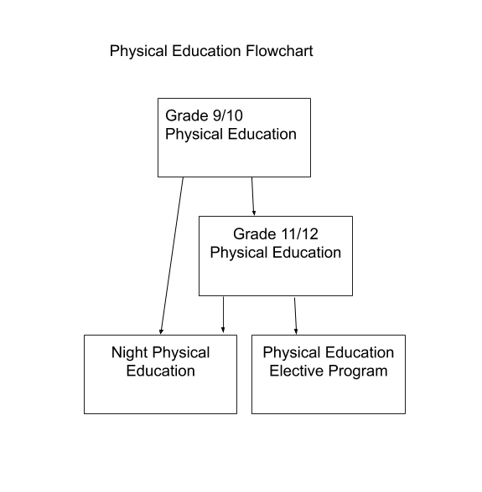
Elective Program
The elective program in physical education is open for all 11th and 12th grade students who have conflicts in their schedule and need PE credit to graduate.
The program will allow greater flexibility in choice of programs. The student is responsible for selecting the specific activity and completing the contractual agreement with the physical education department chairperson. The activity must then be approved by the department before he/she will be eligible to participate in the elective program. To be eligible for the elective program, the student must be in good standing with the Physical Education Department. Although the program is “elective” and the student can set personal goals, the student must be willing to get involved in the activity and remain involved. Most of the activities are lifetime sports and are designed for fun and fitness. Some of the more popular activities have been joining a fitness center, karate, and dance lessons.

Night Physical Education
This program is designed to accommodate students who have conflicts scheduling Physical Education during the regular school day. Some examples are non-traditional students and students who attend BOCES. Night Physical Education is offered daily from 2:40 - 5:00 pm for the entire school year. Students are required to accumulate a total of 60 hours during the school year to receive credit for the course.

Special Education

12:1:1 Special Class
English/Math/Science/Social
This program is designed for students seeking a Regents diploma but may require minimal to moderate behavioral and/or academic needs. The class provides students with a smaller student to teacher ratio. Emphasis is on individual and/or small group instruction in all subject areas required to earn a Regents diploma as it pertains to each student’s individualized education plan. The program can also incorporate half-day pre-vocational or career training.

STEP Program
12:1:1 Grades 9/10 (classroom A)
Grades 11/12 (classroom B)
The STEP Program is designed for students with moderate disabilities who require specialized instruction in all areas, including social-emotional skills, physical skills, academic skills, and daily living skills. Students also participate in half-day pre-vocational and career training. The program utilizes support and transition services with community and state agencies.

12:1 (3:1) Special Class This program is designed for students with multiple disabilities who have high intensity learning needs due to significant cognitive and adaptive delays. This program which is therapeutically based, focuses on fine and gross motor skill development, self-help skills, language development, and socialization skills. Related services may include occupational therapy, physical therapy, speech and language therapy, as well as hearing and vision services. This class includes 12 students with 1 teaching assistant for every 3 students.

15:1 Special Class: English/Math/Social Studies/Science
This program is designed for students with minimal behavior management needs who require specialized instruction within a smaller class setting. Students receive regular education curriculum instruction within a class consisting of 15 students and 1 teacher. Educational curriculum is aligned with New York State Standards.

Integrated Co-Teaching (Inclusion): English/Math
This program is designed for students with disabilities whose learning, social, and emotional needs are best met within the general education program with supportive services. Students participate extensively in the general education program and are required to participate in the state testing program.

5:1 Resource
Grades 9-12
This program is designed for students with disabilities to receive supplemental support outside of the general education classroom. Resource room service is scheduled for one period every day with a ratio of 5 students to 1 teacher. Students in the program participate extensively in the general education program and are required to participate in the state testing program.

CoSer 206 (½ Day Programs through the ARC)
CoSer 206 is a series of transition planning related services designed to meet the mandate of the Part 200 Commissioner’s Regulations on the provision of transitional services to students with disabilities. Services are designed to implement the transition goal of the student’s IEP.

 | STRIDE  Classroom based work/life skills training 1 hr/week | Foundations  ½ day program on MVCC Utica campus | Career OPS  ½ day program at a supervised work site in the community | COLLEGE WORKS  Two-year college-based certificate program for the high school graduate. Located on the MVCC campus
Student’s proposed projected outcome | For the student whose outcome is employment and/or post-secondary education, or community-based day habilitation. | For the student whose outcome is community-based employment or post-secondary education. | For the student whose outcome is community-based employment,  post-secondary education, sheltered workshop or community-based day habilitation program. | For students who want to attend college to improve their job skills and to ob- tain better employment.
Age/Grade | 13-21 years  Grades 7 -12 | 17 -21 years  Grades 11 - 12 | 14 – 21 years  Grades 9 - 12 | Post-secondary
Disability | ID, DD, LD, OHI, ED, Autism | ID, DD, LD, OHI, ED, Autism | ID, DD, LD, OHI, ED, Autism | ID, DD, LD, OHI, ED, Autism
Placement | 12:1:1  8:1:1  15:1  5:1 | 12:1:1  8:1:1  15:1  5:1 | 12:1:1  8:1:1  15:1  5:1 | 12:1:1  8:1:1  15:1  5:1
Services to be provided | 15-week classroom instruction at home school for up to 10 students 1 hour per week. Curriculum focuses on work/life skills and vocational preparation. | 10 months of campus-based and community-based instruction with a focus on employ- ability skills and career exploration. Students are bused by their home district to the MVCC campus. | ½ day program of community-based work experience at one of the four following locations: Holiday Inn,  Price Chopper, St. Elizabeth’s Hospital, or MVCC. Focus is on work readiness skills. | A post-secondary program in partnership with MVCC. Explores careers such as hospitality, janitorial maintenance, caregiver, and office retail.

Science

Beginning with the class of 2005, the New York State Education Department mandates that all students must complete and pass a minimum of three units of science for graduation and pass one Regents science examination. One of the courses must follow a core curriculum, have a minimum of 1,200 minutes of integrated laboratory activities, and end in a Regents exam; these courses are referred to as Regents courses. The student must pass at least one Regents examination, two if working towards the Advanced Regents Diploma. A maximum of two courses may come from the Living Environment (LE) curriculum and one from a Physical Setting (PS) curriculum. In addition to the three units of science, all students are required to complete one-half year of health in grades 11-12.

BASIC COURSES | ADVANCED COURSES
Health | Advanced Placement Biology (LE)
Living Environment 1 (LE) | Advanced Placement Chemistry (PS)
Living Environment 2R (LE) | Advanced Placement Physics (PS)
Living Environment/ Biology R (LE) | (LE)- denotes a course that is part of the  NYS Living Environment Core Curriculum  (PS)- denotes a course that is one of or reflects one of the NYS Physical Setting Core Curriculum
Earth Science R (PS)
Earth Science NR (PS)
Chemistry R (PS)
Chemistry NR (PS)
Physics R (PS)
Physical Science NR (PS)
Living Environment 1 (ELL)
Living Environment 2 (ELL)
Physical Science ELL (PS)
Living Environment Prep
Environmental Science (LE)

Health
The curriculum developed for this course is based on the WHO definition: “Health is a state of complete physical, mental and social well-being, not merely the absence of disease or infirmity.” Thus the elements of physical, social, and mental health are integrated throughout this course study. The student is exposed to many purposeful opportunities and experiences that direct and guide toward a greater appreciation and understanding of healthy living. In addition to classroom instruction, students will hear speakers who are experts in fields related to the study of health. Topics are as follows: mental health, nutrition, drug and alcohol abuse, smoking,physical fitness, communicable and chronic disease, family life education, and first aid training. Emphasis is placed on the improvement of individual health attitudes and habits; prevention is superior to rehabilitation. Required for all students.
- Recommended Grade Level: 11-12
- Evaluation: Local examination
- Credit: ½ unit - ½ year
Living Environment 1 (LE)
Complete and satisfactory documentation of a minimum of 700 minutes of laboratory instruction is required for advancement to Living Environment 2R. Topics covered include ecology, unity and diversity among living things, maintenance of living things, and human physiology.
- Recommended Grade Level: 9
- Evaluation: Local exam
- Credit: 1 unit - 1 year

Living Environment 1 (ELL) (LE) - Same as above, but open only to ELL students

Living Environment 2R (LE)
Completion and satisfactory documentation of a minimum of 600 minutes of laboratory instruction are required and, including LE1, a total of 1,200 minutes for admission into the Regents exam. Topics covered are reproduction and development, genetics, and evolution.
- Recommended Grade Level: 10
- Recommended: Passed Living Environment 1 with lab requirement of 700 minutes.
- Evaluation: Regents and local exam
- Credit: 1 unit - 1 year

Living Environment 2 (ELL) (LE) - Same as above, but open only to ELL students

Living Environment/Biology R (LE)
Complete and satisfactory documentation of a minimum of 1200 minutes of laboratory instruction is required for admission into the Regents exam. Topics covered are those in both LE 1 and LE 2R.
- Recommended Grade Level: 9-12
- Recommended: Final grade of C or higher in Science 8 and a score of 2, 3, or 4 on the NYS Grade 8 Assessment.
- Evaluation: Regents and local exam
- Credit: 1 unit - 1 year
Earth Science R (PS)
Complete and satisfactory documentation of a minimum of 1200 minutes of laboratory instruction is required for admission into the Regents exam. Earth Science is offered for completion of a 3-year sequence in science. The application of earth science concepts and skills such as observation, measurement, graphing, mapping, and classification are emphasized. Topics include geology, weather, energy in the earth, pollution problems, and motions of earth and stars.
- Recommended Grade Level: 9-12
- Recommended: Passed LE 1 and LE2R or Regents Biology and passed the Living Environment Regents
- Evaluation: Regents and local exam
- Credit: 1 unit - 1 year

Earth Science NR (PS)
The course is an introduction to the sciences of geology, meteorology, and/or astronomy as well as current events in earth science.
- Recommended Grade Level: 10-12
- Recommended: Passed LE 1 and LE 2R or Regents Biology and passed the Living Environment Regents exam
- Evaluation: Local examination
- Credit: 1 unit - 1 year
Physical Science for the Non-English Speaker (ELL) (PS)
This course is structured around the current Earth Science curriculum with units in astronomy, meteorology, and geology, with a fourth unit on ecology. The course will use hands-on activities and formal lab work. It will also help prepare students for transition to Living Environment, and the LE Regents exam.
- Recommended Grade Level: 9-12
- Recommended: Directed specifically at our new immigrant populations.
- Evaluation: Local exam
- Credit: 1 unit - 1 year
Chemistry R (PS)
Completion and satisfactory documentation of a minimum of 1200 minutes of laboratory instruction is required for admission into the Regents exam. This course presents a modern view of chemistry using problem-solving approaches, mathematical skills, and lab experiences.
- Recommended Grade Level: 10-12
- Recommended: Successful completion of the Integrated Algebra Regents exam or Algebra
1 Common Core Regents and must have 2 math credits. Accelerated science students who
are not accelerated in math must successfully pass the Integrated Algebra Regents exam
or Algebra 1 Common Core Regents and be enrolled in Geometry.
- Evaluation: Regents and local exam
- Credit: 1 unit - 1 year
Chemistry NR (PS)
This course presents a modern view of chemistry using a problem-solving approach to address various topics mathematical skills to solve chemical problems, and lab experiments to explore the experimental approach to chemistry.
- Recommended Grade Level: 10-12
- Recommended: Successful completion of 2 years of science and successful completion of the Integrated Algebra course.
- Evaluation: Local exam
- Credit: 1 unit - 1 year
Physics R (PS)
Completion and satisfactory documentation of a minimum of 1200 minutes of laboratory instruction is required for admission into the Regents examination. Topics include mechanics, wave phenomena, electricity and magnetism, nuclear physics and geometrical optics. Each topic has laboratory experiments and demonstrations that augment classroom activities.
- Recommended Grade Level: 11-12
- Recommended: Successful completion of 2 of the following Regents: Biology, Earth Science
or Chemistry, and successful completion of the Integrated Algebra Regents exam or Algebra 1 Common Core Regents and the Geometry Regents exam. Trigonometry is also recommended.
- Evaluation: Regents and local exam
- Credit: 1 unit - 1 year
Environmental Science
This course is designed to increase student appreciation of and interest in the interactions of living things with the environment. The student will also understand the role of humans within the natural world and the process of environmental decision-making.
- Recommended Grade Level: 10-12
- Recommended: Successful completion of at least 2 science courses, one of which must be
a physical setting course and passed one Regents exam
- Evaluation: Local exam
- Credit: 1 unit - 1 year
Living Environment Prep
This course is required for all students who have failed the LE Regents exam, but have passed the course. This course is an intensive review of the Living Environment course and will prepare the student to retake the Regents exam in January/June. Students must attend a minimum of 85% of the LE prep classes to be eligible to sit for the Regents exam.
- Recommended Grade Level: 10-12
- Evaluation: Regents exam
- Credit: 0 unit - 1 year
Earth Science for the English Language Learner (ELL) (PS)
This course is designed to introduce students to the four main branches of earth science; astronomy, geology, meteorology, and oceanography. Students will practice real world skills such as map reading, understanding weather maps, disaster preparedness and environmental appreciation. Special attention will be paid to mastering study skills.
- Recommended Grade Level: 11-12
- Evaluation: Local exam
- Credit: 1 unit - 1 year

AP Biology
This is a college-level experience in which the student is exposed to a program designed for Biology majors. Upon successful completion of the course and AP exam, the student may be granted college credit and placed in an upper level course in the freshman year. The class meets daily for one block. Students must be highly motivated and be willing to work hard to succeed.
- Recommended Grade Level: 11-12
- Recommended: Successful completion of Regents Biology, and Chemistry with a minimum grade of 80 on Regents exams
- Evaluation: AP and local exam
- Credit: 1 unit - 1 year
AP Chemistry (PS)
AP Chemistry is a one-credit college-level course taught at the high school. Topics include atomic structure, molecular geometry, thermodynamics, periodic law, electrochemistry, gas laws, organic chemistry, etc. The class meets daily for one block. Students must be highly motivated and willing to work hard to succeed.
- Recommended Grade Level: 11-12
- Recommended: Same as AP Biology
- Evaluation: AP and local exam
- Credit: 1 unit - 1 year
AP Physics
The AP Physics course includes both classical and modern physics. Topics include mechanics, heat and kinetic energy, electricity and magnetism, waves and optics, and modern physics. Each topic is thoroughly presented through a verbal, mathematical, and graphical interpretation of the physical laws. Lab experiments include free fall, projectile motion, ballistics, optics, and others. The class meets daily for one block.
- Recommended Grade Level: 11-12
- Recommended: Same as AP Biology and AP Chemistry, however students should have successfully completed both Algebra, Geometry, and Trigonometry/Algebra 2 courses and have passed the Regents with a minimum of 80%. It is highly recommended that students be enrolled in either Pre Calculus or Calculus.
- Evaluation: AP Physics exam, local exam, and Regents Physics exam if not previously taken.
- Credit: 1 unit - 1 year

SCIENCE FLOW CHART

Accelerated Sequence:

ELECTIVES:

Environmental Science

Nanotech/Microtech

AP Chemistry
Regents Earth Science
Regents
Chemistry
AP Biology

AP Physics
or Regents
Accelerated
8 LE/Biology

Living Environment 1R
ELECTIVES:

Chemistry NR

Environmental Science

Nanotech/Microtech

Living Environment 2R

Social Studies

Four units of social studies are required of each student for graduation. The fourth unit shall consist of one half unit of credit in economics and one half unit of credit in government. Passing grades on the United States History Regents and the Global Studies Regents are required for graduation. A five-credit sequence is available through electives in psychology or two of the three non-required half-year social studies courses: criminal justice and multicultural studies.

Course Offerings
Global Studies 9 R Global Studies 9 R ELL
Global Studies 9 R Honors Global Studies 10 R
Global Studies 10 R ELL AP Euro/Global 10 R
Global Studies 10 R Prep United States History & Government 11 R
AP United States History & Government United States History & Government 11 R ELL
United States History & Government 11 R Prep Government
American National Government dual credit through MVCC
Psychology - grades 11 & 12 Sociology Syracuse University Project Advance (SUPA)
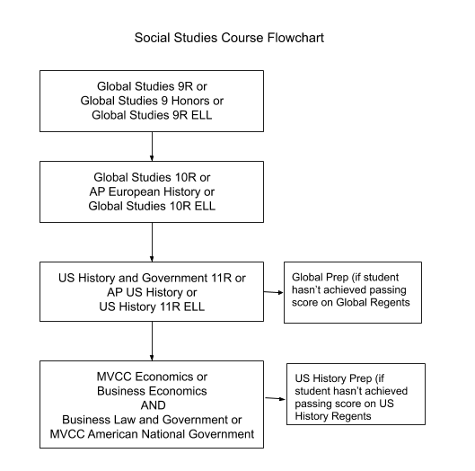

Global Studies 9 R
Phase one of a two-year program. Students study the rise of civilizations to the emergence of the modern world. Themes include geography, economic development, revolutions, religion, government, and social dynamics of change. An emphasis is placed on interpreting documents and writing thematic essays.
- Credit: 1 unit - 1 year

Global Studies 9 R ELL
This course is designed for foreign-born students who have or don’t have the ability to speak English as their second language, but also have a limited background in social studies. Students cover the same program as above.
- Credit: 1 unit - 1 year

Global Studies 9 R Honors
This course curriculum follows NYS Global Studies 9 format and content area with a thematic approach. Emphasis is placed on the use of historical documents to develop skills for historical analysis and position paper fluency.
- Prerequisite: Overall B+ average in the Jr. high program, recommendation from 8th grade teachers
- Credit: 1 unit - 1 year
Global Studies 10 R
Phase two of the global studies program. The course is taught chronologically from the point where Global 9 finishes. Students study the age of revolutions through the contemporary world. Interpreting document-based questions and essay writing are required.
- Recommended: Global Studies 9
- Credit: 1 unit - 1 year

Global Studies 10 R ELL
This course is designed for foreign-born students who have the ability to speak English as their second language but have a limited background in social studies. Students cover the same program as above.
- Recommended: Global Studies 9
- Credit: 1 unit - 1 year
AP European History/Global History 10 R
This is an introductory college-level course designed for those students who wish to pursue a higher level of study. It proposes to develop a greater understanding of global processes and contacts in the context of chronological history in the interaction with different types of societies. It explores major themes of interaction, innovation, revolution, migration, and cultural diffusion in an ever-changing world. If students earn the required grade, they may be granted college credit. Topics include global history in the following time segments: c. 800 B.C.E. - 600 C.E., 600-1750 C.E., 1750-1914, 1914-present.
- Recommended: Grade of B in Global 9 and a B overall average or higher
- Credit: 1 unit - 1 year
Global Studies 10 R Prep
This course is a review for those students who have not yet passed the NYS. Global Studies Regents exam. Global 9 & 10 are reviewed with emphasis on document-based questions and thematic essay writing.
- Credit: N/A

United States History & Government 11 R
This course is designed to develop the students’ understanding of the political, social, economic,and cultural history of the United States. Important topics include: the constitution, supreme court cases, branches of government, and industrialization and the US in the global era. Interpreting documents and essay writing are required.
- Recommended: Global Studies 9 and 10
- Credit: 1 unit - 1 year

AP United States History & Government
This is an introductory college-level course designed for those students who wish to pursue higher-level studies. It is an in-depth chronological study of the events and trends that have affected the development of American ideas and institutions. If students earn the required grade they may be granted college credit by the college of their choice. The topics range from pre-Columbian through the present.
- Recommended: A grade of 88 or above on the Global Regents and has maintained a B+ average in all courses
- Credit: 1 unit - 1 year
United States History & Government 11 R ELL
This course is designed for foreign-born students who have the ability to speak English as their second language but have a limited background in social studies. Students cover the same material as in U.S. History 11 Regents.
- Recommended: Global Studies 9 and 10
- Credit: 1 unit - 1 year
United States History & Government 11 R Prep
This course is a review for those students who have not passed the NYS United States History Regents exam. An overview of U.S. History themes are covered with emphasis on document-based questions and essay writing.
- Credit: N/A
Government
Students study how public policy is defined, developed, and applies in our system of government. Emphasis will be placed on issues of state, county, and city government. A course project may include community service/research project/internship.
- Recommended: Social Studies 9, 10, and 11
- Credit: ½ unit – ½ year
American National Government Dual-Credit through MVCC
The objective of this course is to introduce students to the discipline of political science through the study of American government. The course will cover the following topics: the concept of the political system, democracy in theory and practice, the historical background and content of the constitution, federalism, and the supreme court’s role in the area of civil rights. For additional information, refer to the MVCC catalog of courses under PS101. Dual credit courses are college courses offered at the high school that meet both the graduation requirements of the high school and begin building college credit requirements.
- Prerequisite: Social Studies 9-11 and an overall B+ average
- Credit: ½ unit high school/college credit - ½
Sociology
Syracuse University Project Advance (SUPA). This is a dual-credit course in conjunction with Syracuse University. There is a substantially reduced tuition cost required. Financial aid is available. This course will emphasize the study of social institutions (i.e., marriage, family). Themes of study include division of race, gender, and social classes. The emphasis is on analytical reading and conceptual analysis. Syracuse University credit will be earned upon successful completion of the course. The credits are transferable to other colleges and universities.
- Prerequisite: Seniors with an overall B+ average. Juniors upon availability, B+ average, and on a college path.
- Credit: ½ unit - ½ year

OHM BOCES Career Pathways/Tech Prep Program
The Utica City School District participates in the Oneida-Herkimer-Madison BOCES Career Pathways / Tech Prep Program. More than 80% of the jobs in this century will require more knowledge about business, science, math, and technology. A federally funded and regulated program, Career Pathways / Tech Prep is a major reform effort to address the needs of students for quality academic and technical studies that will prepare them for further education and work. All of these programs are 2+2 programs of study that combine 2 years of secondary education with a minimum of 2 years of post-secondary education in a non-duplicative, sequential course of study. Career Pathways / Tech Prep courses integrate academic and technical instruction and utilize work-based learning experiences as well as technical preparation in technology and business. The Career Pathways / Tech Prep Program helps students develop competence in math, science, and English through applied, contextual courses. Articulation agreements between secondary and post-secondary schools ensure that students receive non-duplicative, sequential instruction. Students who complete four courses of study in technology or business are eligible to receive the Career Pathways / Tech Prep certificate upon graduation. Students receiving the Career Pathways / Tech Prep certificate may be eligible for a scholarship awarded by the program. Career Pathways / Tech Prep students receive assistance attaining articulation credit from the program. These students also receive assistance attaining articulation credit from MVCC and may also be eligible to participate in a Summer Technology Camp.

To earn a Career Pathways / Tech Prep certificate at the completion of high school at Proctor, students must:
- Earn credit for 3 years of Regents math
- Earn credit for 3 years of Regents-level science
- Participate in a full-day shadowing experience at a work site arranged through SABA
- Earn a minimum of 4 credits in technology or business
- Complete a portfolio that highlights the student’s best work from technology/business Tech Prep program

This program provides meaningful educational opportunities that help young people succeed in both college and work. This program allows students to save time and tuition dollars by taking challenging, real-world coursework in high school. By completing a 4-unit sequence in technology, business and/or communications, high school students jump-start their careers and build the skills they need to be successful in college. Many times, colleges may accept college credit for Tech Prep courses through either articulation agreements or dual credit arrangements

Certification Requirements
- 4 units in Tech Prep curriculum area (technology, business and/or communications)
- 3 units of math
- 3 units of science
- A one-day job shadowing experience through the SABA program
- A portfolio of your best work
The highly skilled workplace of today requires a good understanding of technology, business and/or communications. Put your time in high school to good use and take the Tech Prep courses that will give you an important advantage in college and in life. Expand your options by enrolling.

Social Studies Acceleration Guidelines Grade 9
Acceleration Eligibility Criterion
- 85% or higher on 8th grade final Social Studies examination. The same final will be given consistently at both middle schools.
- Cumulative B+ average in 7th and 8th grade Social Studies.
- Level 3 or 4 on the 8th grade State Assessment.*
- Excellent work ethic and 85% attendance.

Parental Consent
- Student participation in accelerated coursework requires written parental consent.
- The building principal is to secure written parental consent after the student is determined eligible for accelerated status.

Discontinuance of Acceleration Status Due to Performance
- Continuation of student in accelerated status will be monitored and reviewed by the classroom teacher the first and second marking periods of grade 9 Social Studies.
- After the first marking period, if the student is not rendering satisfactory performance, counselor and building principal will be notified by teacher and an immediate parent/ teacher conference will be scheduled.
- After the second marking period, if student is not meeting eligibility criteria, he or she will be placed in a regular paced Social Studies class as per add/drop policy.

Accountability
- Classroom teachers submit quarterly acceleration reports to building principal.
- Principals submit an Acceleration Status Quarterly Report to Director of Curriculum & Instruction K-12.

Footnotes
- Final scheduling of students will not occur until after the end of th year when all final exam results are available.
- Acceleration in any subject is not dependent on acceleration in another subject.

English Acceleration Guidelines Grade 9

Acceleration Eligibility Criterion
- 85% or higher on 8th grade final English examination.
The same final will be given consistently at both middle schools.
- Cumulative B+ average in 7th and 8th grade English.
- Level 3 or 4 on the ELA Assessments in both 7th and 8th grade.
- Excellent work ethic and 85% attendance.

Discontinuance of Acceleration Status Due to Performance
- Continuation of student in accelerated status will be monitored and reviewed by the classroom teacher the first and second marking periods of grade 9 English.
- After the first marking period, if the student is not rendering satisfactory performance, counselor and building principal will be notified by teacher and an immediate parent/ teacher conference will be scheduled.
- After the second marking period, if student is not meeting eligibility criteria, he or she will be placed in a regular paced English class as per add/drop policy.

Mathematics Acceleration Guidelines (Grades 7-9)

Acceleration Eligibility Criterion
- 85% or higher on 8th grade final English examination.
The same final will be given consistently at both middle schools.
- Cumulative B+ average in 7th and 8th grade English.
- Level 3 or 4 on the ELA Assessments in both 7th and 8th grade.
- Excellent work ethic and 85% attendance.

Continuing Acceleration Status Requirements (7th - 8th Grade):
- 85% or higher on the grade 7 final Mathematics examination.
- Cumulative B average in Mathematics.
- Level 3 or 4 for the prior 2 years in the New York State Mathematics Assessment.
- Excellent work ethic and attendance.

Grade 9 Math Course Placement (8th Grade - 9th Grade):
- Cumulative C+ or higher average in Algebra. C+ requirement will be reviewed after
evaluations the state-mandated Algebra course.
- A passing score on the Algebra CC Regents exam.
- Teacher sequence recommendation.
- Excellent work ethic and attendance.

Discontinuance of Acceleration Status Due to Performance
- Continuation of student in accelerated status will be monitored and reviewed by the classroom teacher the first and second marking periods.
- After the first marking period, if the student is not rendering satisfactory performance, counselor and building principal will be notified by teacher and an immediate parent/ teacher conference will be scheduled.
- After the second marking period, if student is not meeting eligibility criteria, he or she will be placed in a regular paced Mathematics class as per add/drop policy.

Science Acceleration Guidelines (Grades 7-8)

Acceleration Eligibility Criterion
- 85% or higher on the 6th grade final Science examination. The same final will be given at both middle schools.
- Cumulative B+ average in 6th grade Science.
- Level 3 or 4 on the grade 4 Science Assessment and on the 5th Grade Mathematics Assessment.
- Must meet Accelerated Mathematics Guidelines.
- Excellent work ethic and 85% attendance.

Continuing Acceleration Status Requirement
Seventh Grade into Eighth Grade:
- 85% or higher on final 7th Grade Science Examination.
- Cumulative B average in Grade 7 Science.
- Level 3 or 4 on the New York State Grade 8 Science Assessment. Accelerated students take the Grade 8 Science Assessment in 7th grade.
- Excellent work ethic and 85% attendance.

Discontinuance of Acceleration Status Due to Performance
- Continuation of student in accelerated status will be monitored and reviewed by the classroom teacher the first and second marking periods.
- After the first marking period, if student is not rendering satisfactory performance, counselor and building principal will be notified by teacher and an immediate parent/ teacher conference will be scheduled.
- After second marking period, if student is not meeting eligibility criteria, he or she will be placed in a regular paced Science class.

Guidance and Related Services

Program Planning
The guidance department is a clearinghouse for questions relating to subject choice and program planning. An important task of the counselors is to help students interpret course offerings in view of their own educational and career plans. The guidance department provides source materials and information concerning career opportunities and training beyond high school. Individual scheduling conferences are held with all students. Parents are encouraged to attend.

Individual schedules must be completed for all students in grades 9-12. Further counseling is necessary in cases of conflict in subject choice or in the event of course failure. Students with course failures may be advised to attend summer school, repeat courses next term, or change their programs. Students in this category should contact their guidance counselor as soon as their status is known.
Support Services
Special services are available to students in areas of personal counseling, individual testing, and assistive therapies as needed as well as to students who are specifically classified by the district’s Committee on Special Education. These services are administered by specialists, usually on an individual basis. Any parent or student may request these services by contacting his/her individual guidance counselor.
Course Selection Procedures
Student selection of courses typically takes place in early spring. Counselors meet with students to review previously completed coursework and the requirements for graduation. Parents are encouraged to participate in this process. Notification will be sent home when the process begins.
Graduation Requirements
The Board of Education and the New York State Regents minimum standards are required for graduation from high school. All school programs have one main purpose even though they provide a variety of experiences. This purpose is to help students develop and acquire the skills, abilities, knowledge, and attitude necessary to work toward high school graduation. A student’s eligibility for a diploma will be determined by the high school principal on the basis of the official high school record. Students who meet the requirements will be issued a diploma.

Diploma and Graduation Requirements
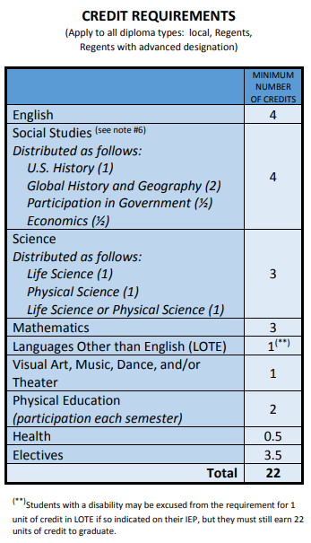
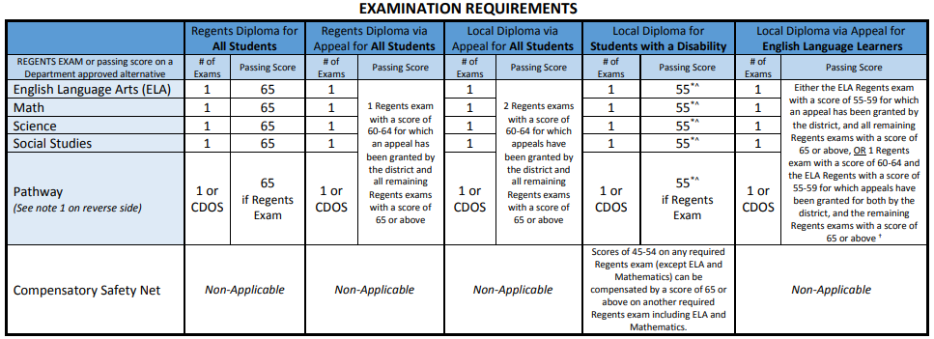
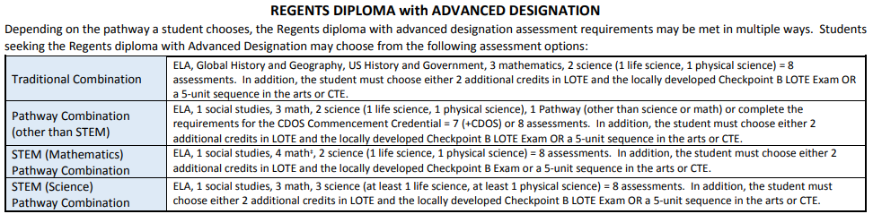
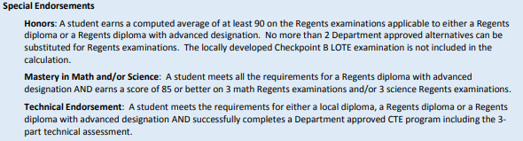
Multiple Pathways
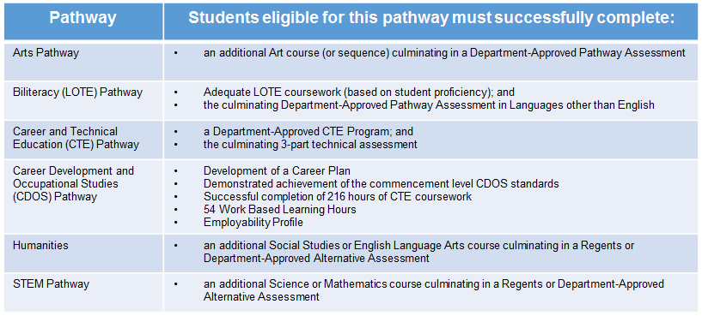
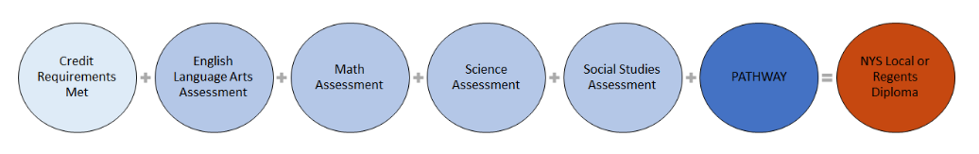

Regent

